Hospital Appointment System

User Manual

Table of Contents

**User Manual 1**

Section 1: Introduction 311

System Requirements (For I.T. Department) 311

Installation Instructions (For I.T. Department) 311

Section 2: Using the Program 312

Common Functions 312

Login Screen 313

Logging In 314

Main Menu 315

Patients Form 316

Creating a Patient Record 317

Advanced Search 318

Appointments Form 322

Creating an Appointment Record 323

Generating Letters and Labels 323

Checking if Dates Conflict 325

Clinic Records Form 326

Attaching a Picture 327

Creating a new Clinic Record 328

Creating a Doctor Holiday/Leave record 328

Creating a Backup 329

Backup Plan 331

Section 3: Appendix 332

Error Messages 332

Error Message Images 334

# Introduction

The ‘Hospital Appointment System’ will allow you to keep up to date information of all appointments. The features of the program include the following:

* Admins have the ability to create, edit and delete records of patients, clinics, doctors, appointments, medical records, medicine usage and test results
* You can check if appointment times and dates are checked for conflicts with other appointments
* You can generate the appropriate appointment letters at the click of a button
* You can search the database in numerous ways to find specific records(s) through the user of definable criteria
* Doctors are able to view any appointments that are assigned to them
* You can add holiday dates for doctors such that the system will not have any conflicts when a patient is assigned an appointment at the time when a doctor is unavailable
* A secure login system where admins can change passwords and create new accounts
* A simple, easy to read information overview for patients, clinics and appointments
* Data is validated before each record is saved to reduce the frequency of incorrect data entry
* You can back up the system at the click of a button.
* Summary report can be produced surmising the amount of records of clinic, patients and more

# System Requirements (For I.T. Department)

* Windows XP or later versions of Windows
* Minimum of 20mb of free space for the database
* Microsoft Access 2010 or later versions of Microsoft Access

**Installation Instructions (For I.T. Department)**

* Add “Hospital Appointment System.accde” onto the network so that all users are able to access the program
* Open up the program and add make sure the following references are checked: Visual Basic for Applications, Microsoft Access 14.0 Library, OLE Automation, Microsoft Office 14.0 Access database engine Object Library, Microsoft Word 14.0 Object Library, Microsoft Office 14.0 Object Library. This can be done by navigating to the visual basic code screen then going to “Tools 🡪 References”
* Add the “Hospital Appointment System Source.accde” onto the network and set the file properties to “Read-Only”.
* Add the word templates “Appointment.dotx”, “DNA.dotx”, “First.dotx” onto the network and set their properties to “Read-Only”
* Update “Hospital Appoint System.accde” to reflect the file path(s) of the word templates and the “Hospital Appointment System Source.accde” file if needed.
* Create new user accounts for all users with the appropriate user privileges.

**Using the Program**

Common Functions

2 – Save and Close Window

1 – Save and New Record

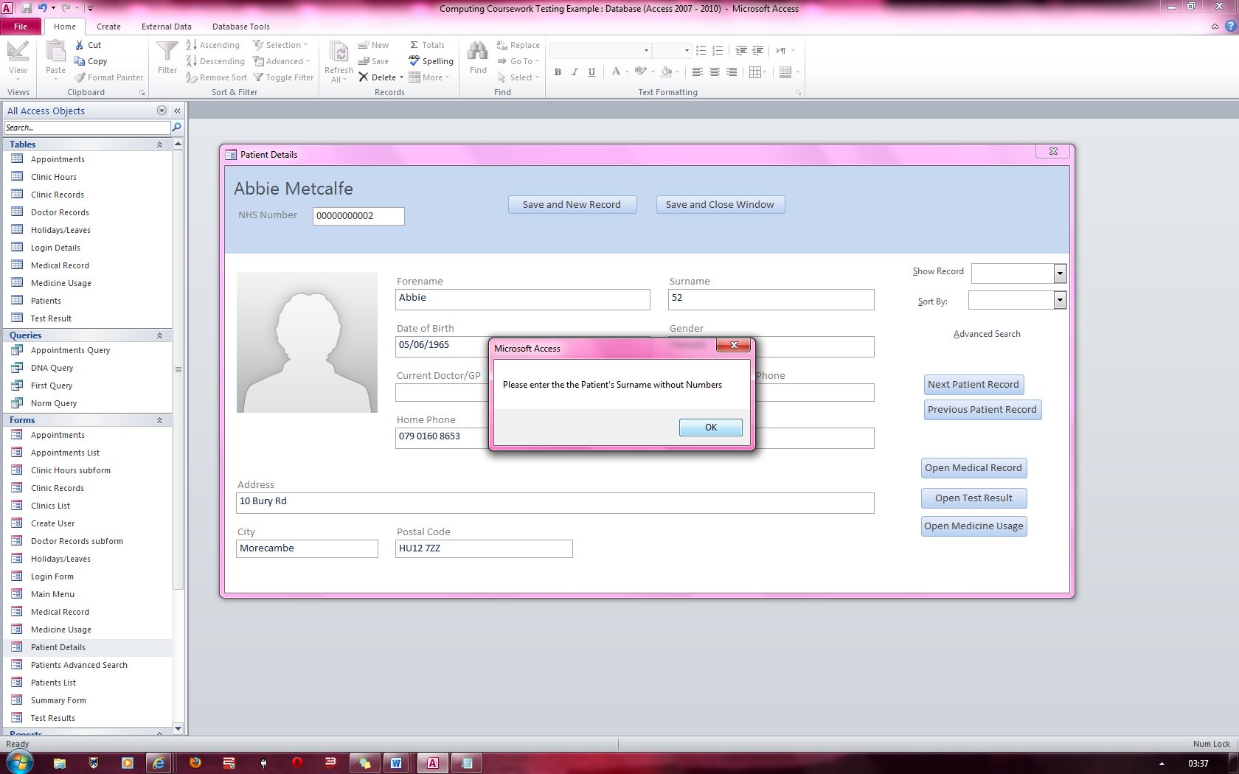

**1 – Save and New Record:** When this button is clicked, it saves the current record and navigates to a new record.

**2 – Save and Close Window:**  When this button is clicked, it saves the current record and closes the current window

5 – Open Form

4 – Previous Record

3 – Next Record



**3 – Next Record:**  When this button is clicked, it navigates to the next record.[1]

**4 – Previous Record:**  When this button is clicked, it navigates to the previous record.

**5 – Open Form:** When this button is clicked, it opens up the appropriate form.

Login Screen[2]

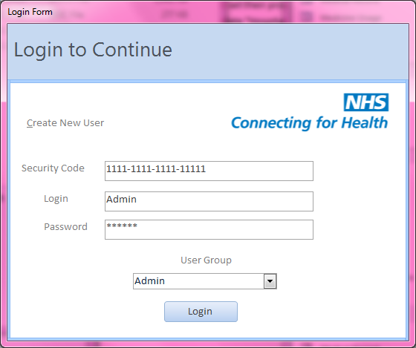

3 - Login

6 – Login Button

1 - Create New User

2 - Security Code

5 – User Group

4 - Password

Before having full access to the hospital appointment system, you will be greeted by a login screen which requires you to input your unique login details as well as your “Security Code”.

**1 – Create New User:**  Clicking this will bring up a popup menu of the “Create user” form which will allow admins to create new users with the appropriate login privileges.

**2 – Security Code:** In this textbox, the user must input their unique security code which consists of 17 characters (not including the dashes)

**3 – Login:** In this textbox, the user must input their login name.

**4 – Password:** In this textbox, the user must input their password which must be in the range of 6 to 24 characters.

**5 – User Group:**  This is a drop down list which contains two options to select from: Doctor and Admin. One of the two must be selected before logging in.

**6 – Login Button:** This button initiates the login process.

Logging In

1. Enter a valid security code such in the security code text box. [3]
2. Enter a valid login name in the login text box.
3. Enter a valid password
4. Select the user group you have been assigned to.

If all the above steps are done, a message should appear notifying if the login has succeeded or an error message should appear if it has failed. If a login is successful, the main menu should appear.

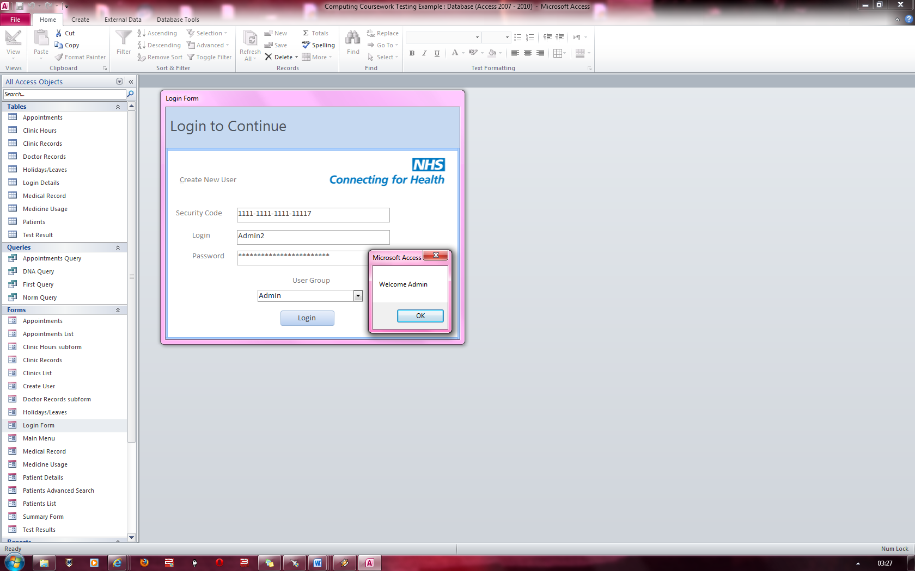

The image to the left shows a demonstration of a successful Administrator login.

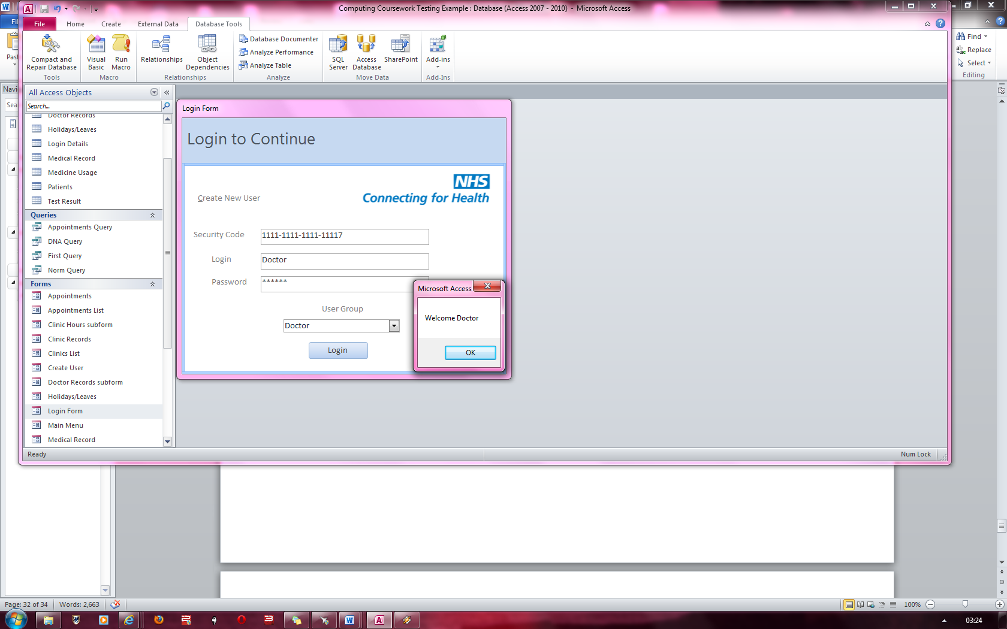

The image to the left shows a demonstration of a successful Doctor login.

Main menu

3- Return to Login Screen

2 - Exit

1 - Tabs

4 - Create Backup

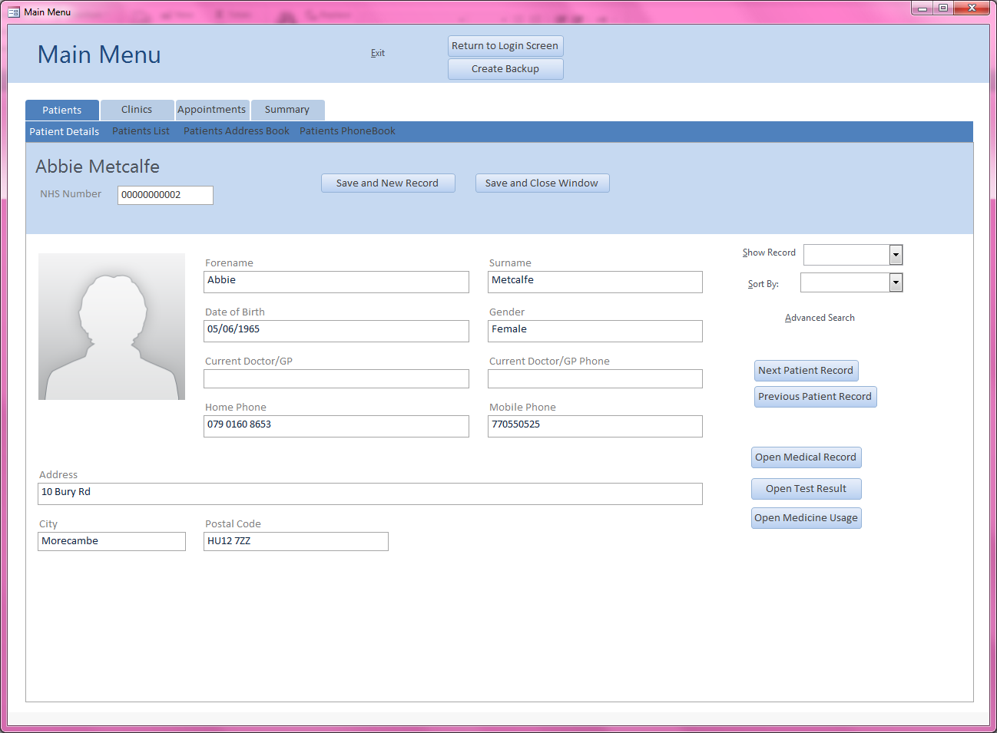

*Included in this image is the patients form which will annotated further into the manual*

**1 – Tabs:** This is the primary form navigation tool. By clicking on a tab, related tabs will appear which when clicked produce the appropriate form as shown above.

**2 – Exit:**  When “Exit” is clicked, the program closes the main form.

**3 – Return to Login Screen:**  When this button is clicked, the login screen will appear in the form of a popup.

**4 – Create Backup:**  When this button is clicked, the backup process will initiate. This process is covered on page 20

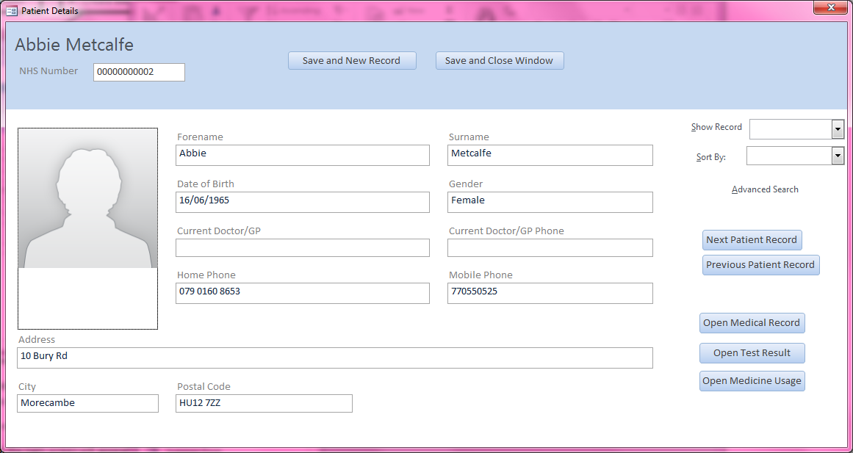Patients Form[4]

1 – Patient Image

3 – Show Record

2 – Sort By

4 - Text boxes

6- Form Navigations

5 – Advanced Search

The “Patient Details” form allows you to add, edit and delete records of patients. There are also numerous ways in which you can navigate to specific records.

**1 – Patient Image:**  Clicking this will bring up a dialog box with the option of placing an image onto the system which is used to represent the patient. By default, the above picture is used.

**2 – Sort By:** This drop down box has a set of criteria which you may sort the records by.

**3 – Show Record:** This drop down box shows a list of all the records for easier viewing. Clicking on a record will bring up information about that patient.

**4 – Text Boxes:** The text boxes only allow specific types of data to be entered into them such as forename does not allow the field to be empty or contain letters

**5 – Advanced Search:**  When clicked, this opens the “Advanced Patient Search” form which is covered on page 9

**6 – Form Navigations:** These buttons open up the following forms respectively: Medical Record, Test Results and Medicine Usage

Creating a Patient Record

1. Click the button “Save and New Record”
2. Enter valid details into all the textboxes and add a patient image if required.
3. 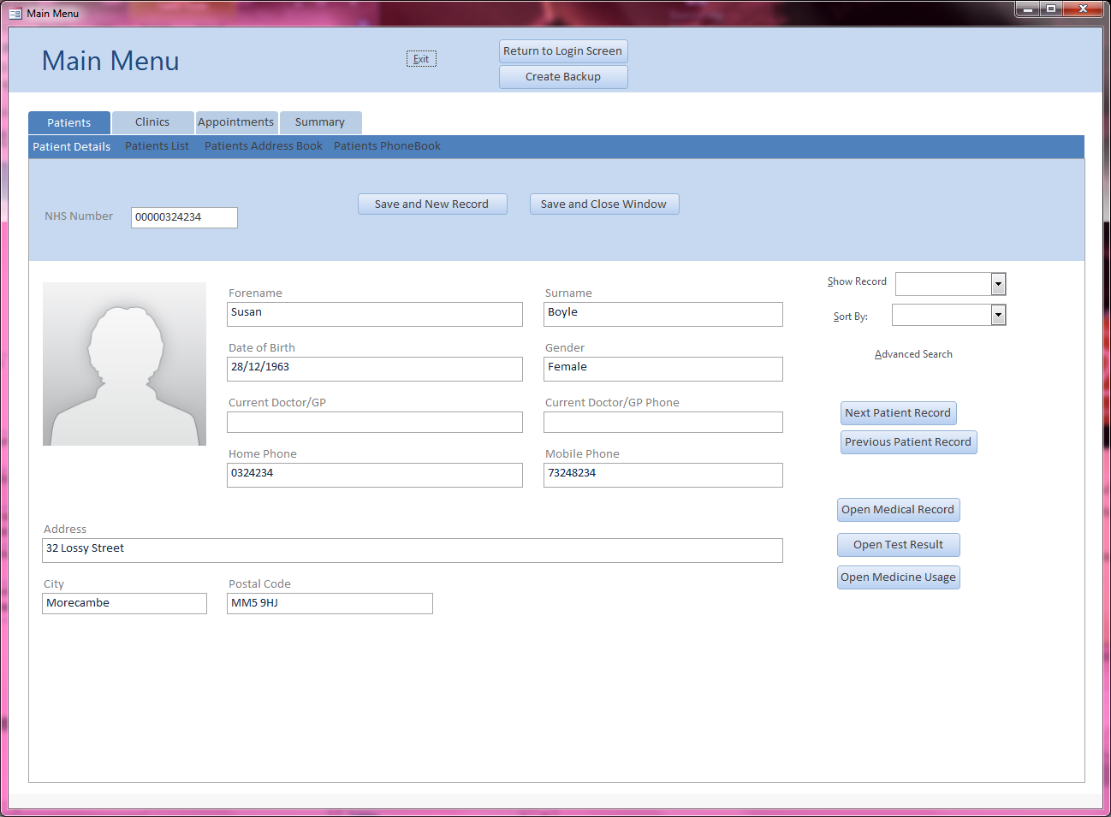Click save and close window

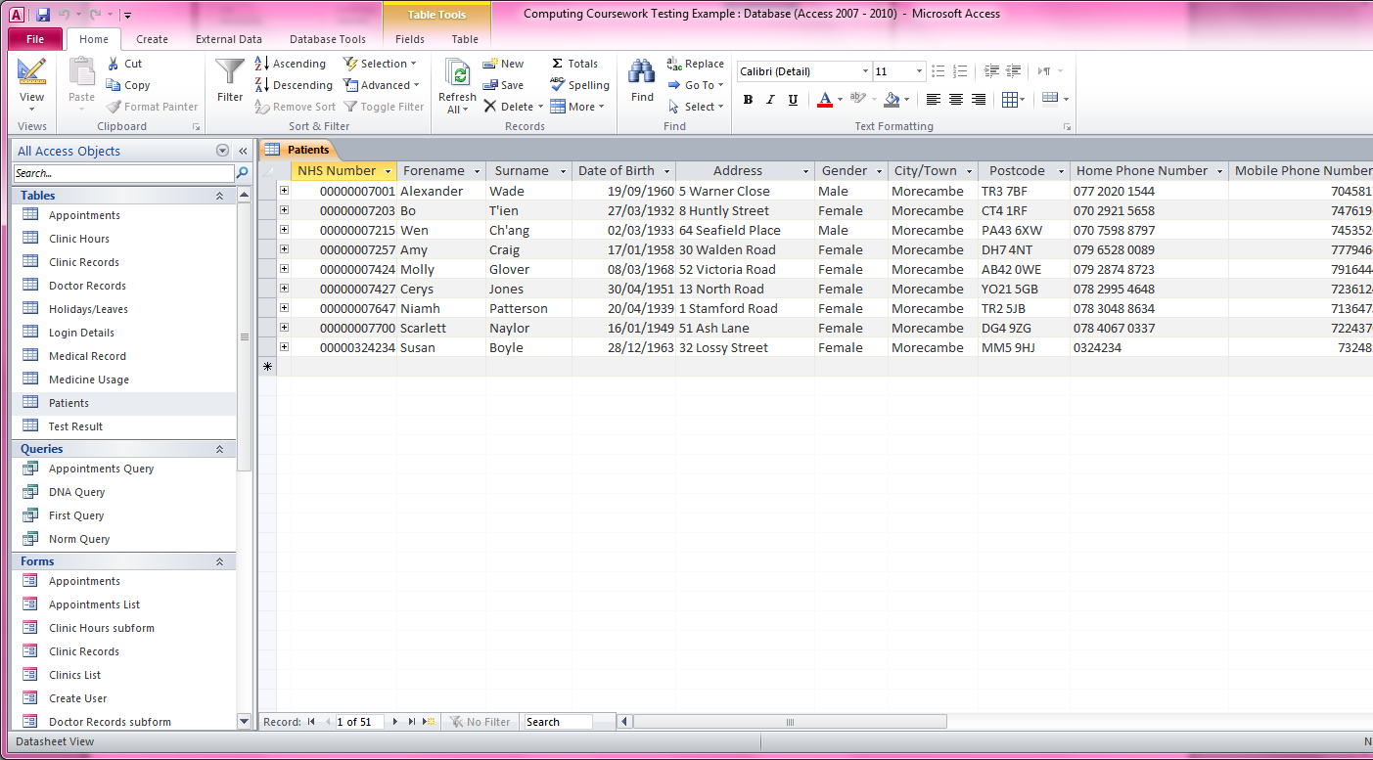In the above image, details have been entered onto the form after the button “Save and New Record” had been pressed.

Here the record was saved into the database along with the other records.

Advanced Search[5]

This feature allows you to run a search where you may define the criteria the system will look for.

Multiple Item Search View

2 - Multiple Search

1 – Search Criteria

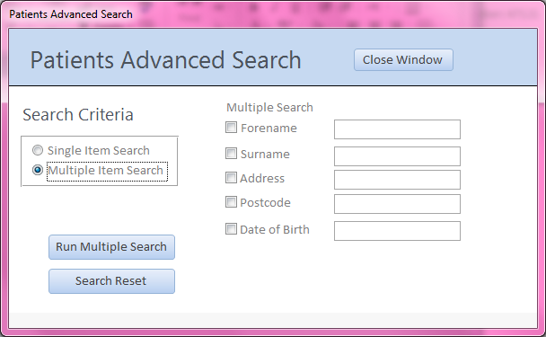

4 – Search Reset

3 – Run Multiple Search

**1 – Search Criteria:** This box contains two options to choose from which when clicked bring up the appropriate search functions.

**2 – Multiple Search:**  This section contains criteria which you are able to search by. You must check the appropriate tick boxes and enter some data into the related textboxes in order to bring up a search result.

**3 – Run Multiple Search:**  When this button is clicked, the search initiates and if successful, the patient details form will pop up with patients who have the same information that you searched for.

**4 – Search Reset:**  This removes all data entered into the search boxes and unchecks all the check boxes.

Single Item Search View

1 – Single Search

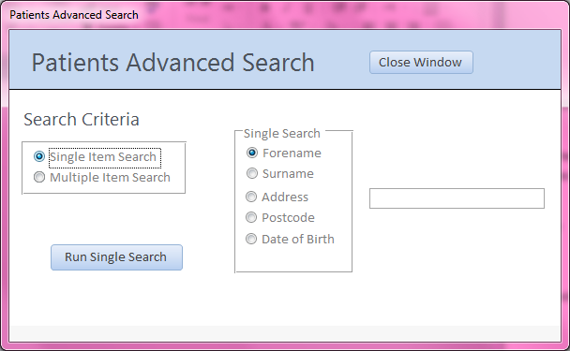

**1 – Single Search:** This is an option box which only allows you to select one of the options. You may then type some criteria into the textbox on the right and then click on the “Run Single Search” button to initiate the search process.

Using Multi Search and Single Search

Single Search

1. In the “Search Criteria” option box, select “Single Item Search”.
2. Choose one of the options in the “Single Search” panel.
3. Enter the relevant data into the textbox.
4. Click on “Run Single Search” to initiate the search process.

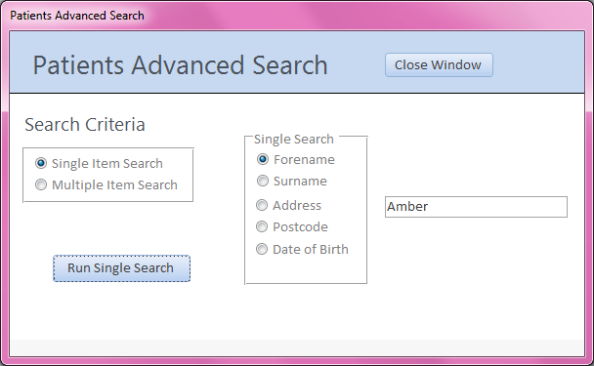In this case, two results were returned as shown below. To check if multiple records were found, you 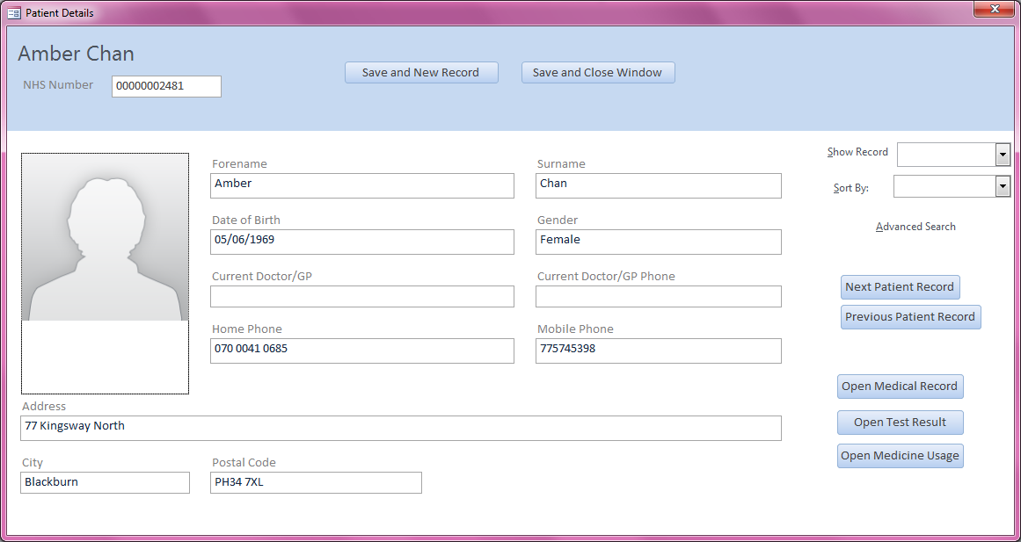can just press the next or previous button which will navigate to the next record with the criteria you 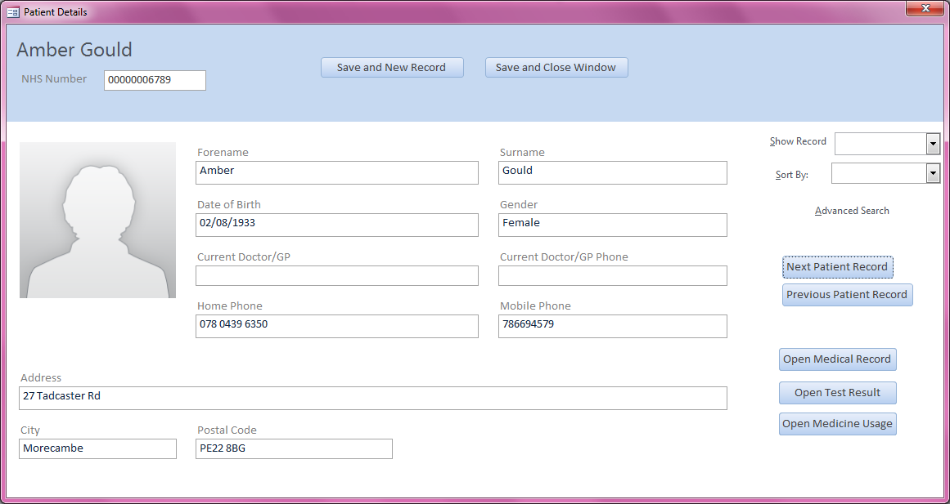entered into the search box.

This will search through the database of records for all patients with the name “Amber

Here both Amber Chan and Amber Gould were found.

Multi Search

1. In the “Search Criteria” option box, select “Multiple Item Search”.
2. Choose any number of the options in the “Multiple Search” panel.
3. Enter the relevant data into the textbox(s).
4. Click on “Run multiple Search” to initiate the search process.

A demonstration is available below.

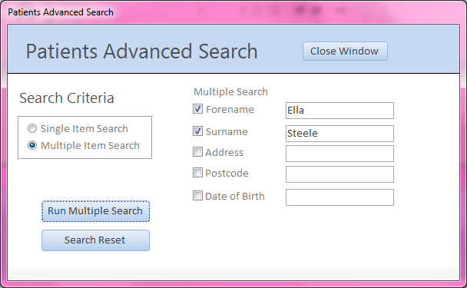

This will search through the database of records for all patients with the Forename “Ella” and Surname “Steele”

As shown below, only one record was found through this process.

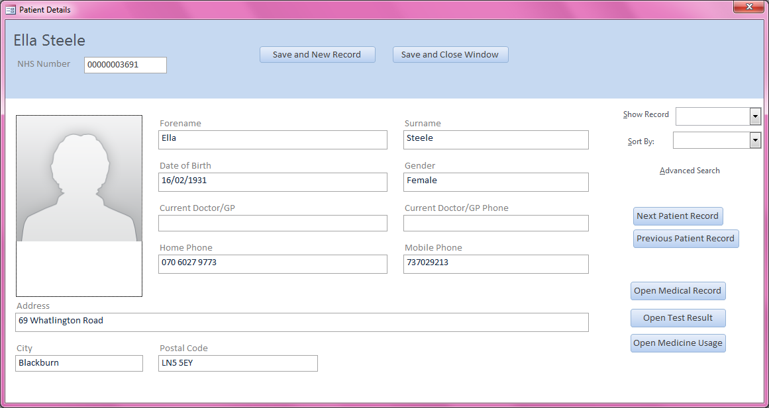

Appointments Form[6]

This form enables you to: create, edit and delete appointments; generate appropriate letters for appointments as well as appropriate letter labels; check if the appointment dates and times do not conflict with other appointments at the same clinic and allows you to sort the appointments through different criteria.

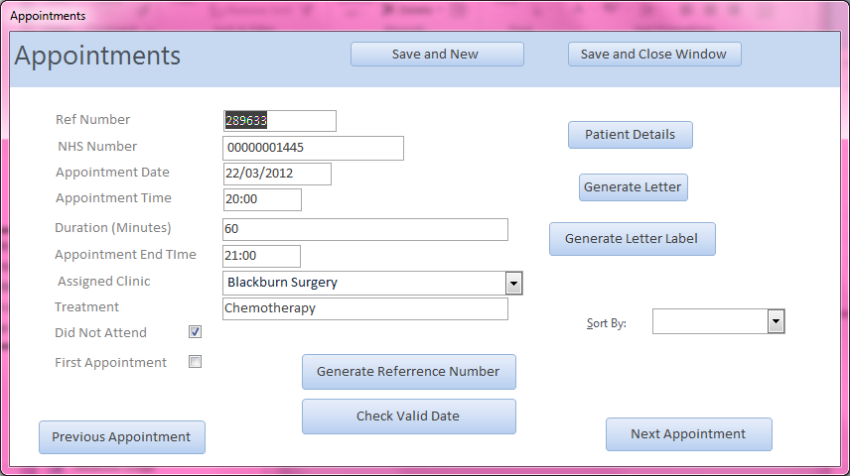

3 – Generate Letter Label

1 – Text boxes

4 – Check Boxes

6 – Generate Reference Number

5 – Check Valid Date

2 – Generate Letter

**1 – Text Boxes:** These allow you to enter the relevant information into them. All the data entered here is validated to reduce incorrect data entry.

**2 – Generate Letter:**  This button creates a letter with the information of the patient whose appointment is listed on the current window. The type of letter depends on if the check boxes are checked or not.

**3 – Generate Letter Label:**  When this button is clicked, the system creates a label which includes the patient’s address and name and allows you to print the label.

**4 – Check Boxes:**  These check boxes are used to tell the system whether or not it needs to generate a “Did not attend” letter, a “First Appointment” letter or just a normal appointment letter.

**5 – Check Valid Date:**  When this button is clicked, the system checks if the current date and time and clinic entered conflicts with another appointment and states which appointment conflicts if it does.

**6– Text Boxes:** When clicked, this button generates a reference number in the range 1 to 1,000,000 and places it inside the “Ref Number” text box.

Creating an Appointment Record

Creating an appointment is a simple process and follows the same process which is used to create a patient record on page 8

Data types which can be entered into specific fields are demonstrated on page 13.

Generating Letters and Letter Labels

1. Specify which letter you wish to generate by checking or unchecking the relevant check boxes.
   1. “First Appointment” Letter – Check “First Appointment”
   2. “Did not Attend” Letter – Check “Did not Attend”
   3. “Normal Appointment” Letter – Make sure both text boxes are unchecked
2. Enter valid details for the appointment
3. Click on generate letter to produce the relevant letter
4. Click on generate letter label to produce a letter label.

To demonstrate this procedure, I will be using a record previously created on page 8 of the user manual and I will generate the “Normal Appointment” letter.

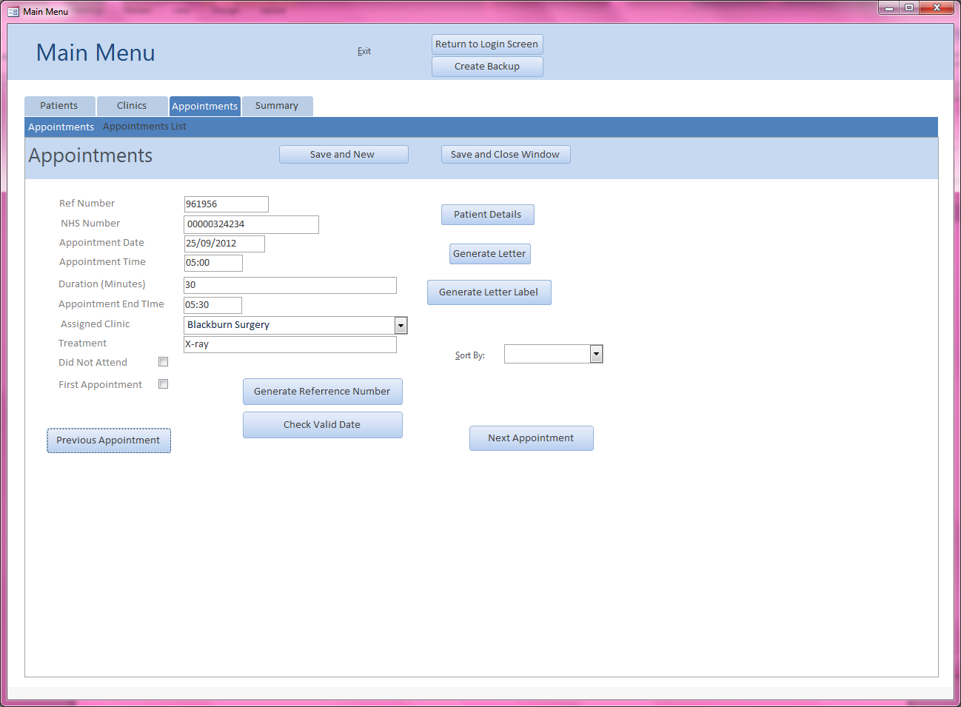

Valid details have been entered into the text boxes and both check boxes are kept unchecked so that the program will generate a “Normal Appointment” letter.

Below the letter has been generated after the “Generate Letter” button has been clicked

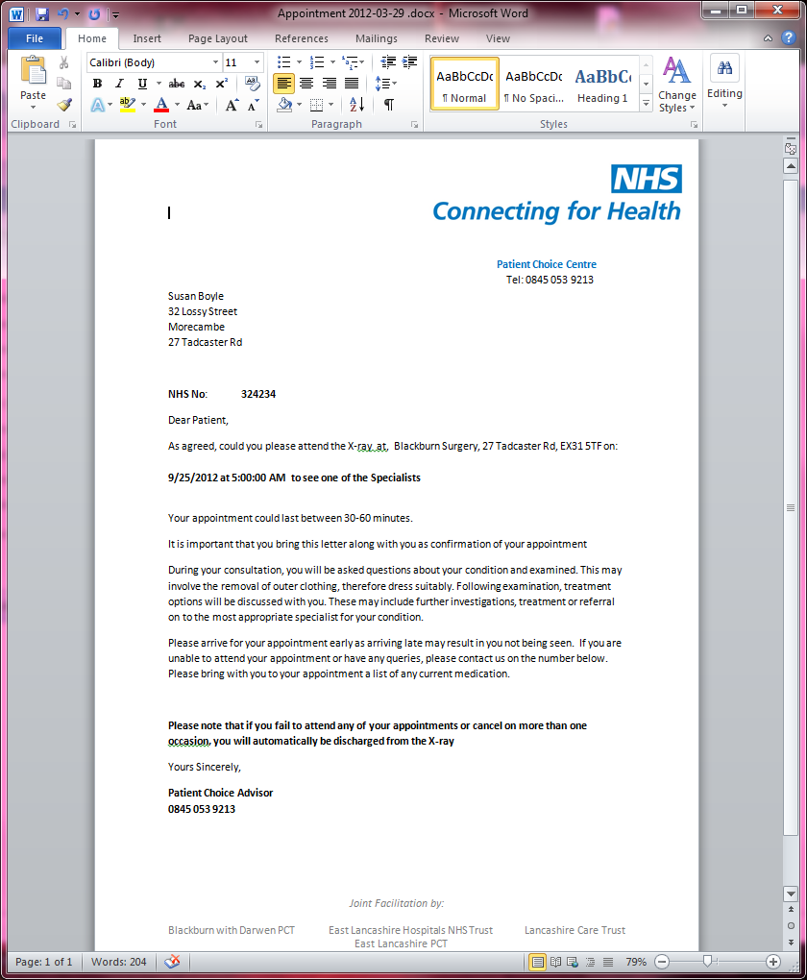

The relevant letter label has also been generated with the patient’s full name and address. An option to print is also available.

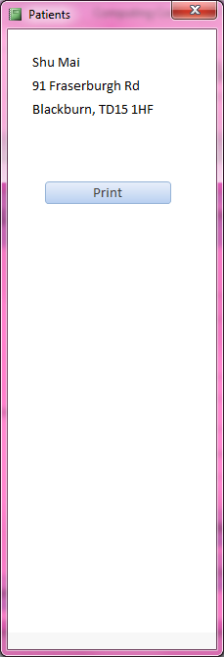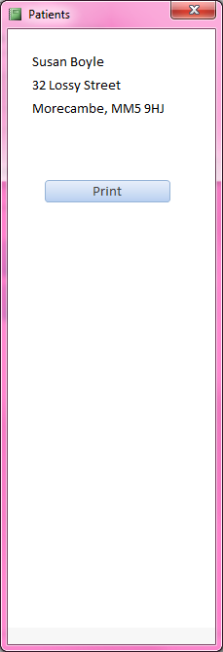

This is the “Normal Appointment” template letter which has taken the patient’s details from the database and entered them into the letter.

Checking if Dates Conflict[7]

1. Enter some appointment details into the appointment form
2. Click on “Check Valid Date

If the date does not conflict with any other date and time at the same clinic, then a message will appear stating that the appointment is available.

Below is a demonstration of a circumstance where a date, time and clinic will not conflict.

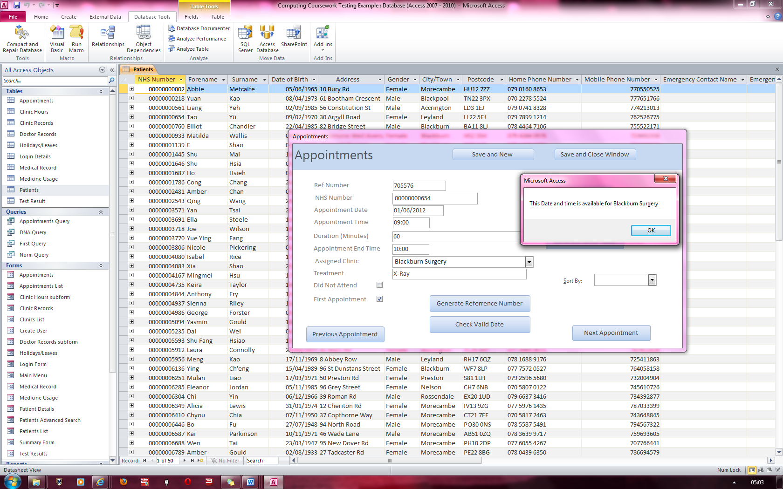

After entering some valid appointment details and a non-conflicting date and time and clinic name, a message appears stating that the date and time is available for the surgery specified.

Clinic Records Form

This form is used to: create, edit and delete clinic records; sort clinic records by specific criteria; view the employed doctors of a specific clinic; add holidays and leaves for doctors as well as view a doctor’s timetable.

2 – Attach Picture

1 – Text boxes

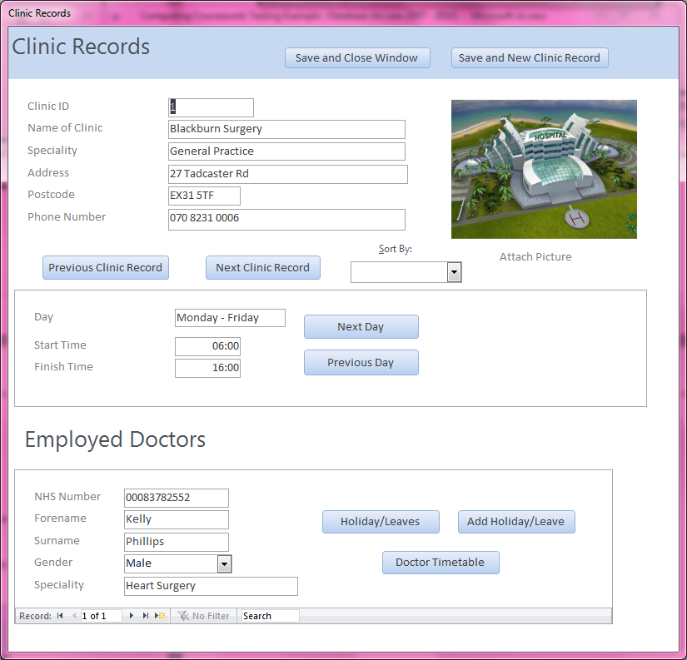

6 – Doctor Timetable

5 – Add Holiday

4 – Holidays

3 – Days Open & Time

**1 – Text Boxes:** These allow you to enter the relevant information into them. All the data entered here is validated to reduce incorrect data entry.

**2 – Attach Picture:**  This button allows you to attach a picture of the clinic.

**3 – Days Open & Time:**  This section of the form allows you to modify the opening days and navigate through the records.

**4 – Holidays:**  When this button is clicked, the “Holidays/Leaves” form is brought up if the doctor on the current record selected has any past, present or future holiday records.

**5 – Add Holiday:**  When this button is clicked, the system brings up the “Holiday/Leaves” form and automatically fills in the “NHS Number” field on the form and allows you to add a “Holiday/Leave” either for the present date or for a future date.

**6– Doctor Timetable:** When clicked, this button opens up the appointment form to appointments that are at the Doctor’s surgery.

Attaching a Picture

1. Double click on the default icon for the clinics
2. Click on “Add” and navigate to the location of the Clinic’s picture
3. Click on “Save All” and then press “OK”

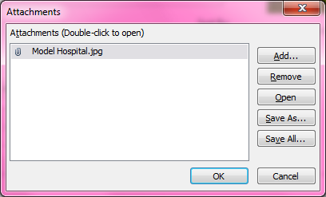

On double clicking the default image for the Clinic/Hospital, a dialog box is brought up such as the one above. From here, you click on “Add...” and navigate to the location of the image in the new file dialog box.

Create new Clinic Record

Creating a new clinic record is a simple process and follows the same process which is used to create a patient record on page 8

Data types which can be entered into specific fields are demonstrated on page 17.

Creating a Doctor Holiday/Leave record[8]

1. Click on “Add Holiday/Leave” which will bring up a blank “Holiday/Leave” form with only the NHS number automatically entered into the relevant field.
2. Enter a leave date which is either at the current date or at a future date.
3. Enter a return date which is further ahead of the entered leave date
4. Change the default “No Reason Stated” in the “Absence Reason” textbox to the reason for the holiday/leave.
5. Click on “Save and Close Window” to save the changes.

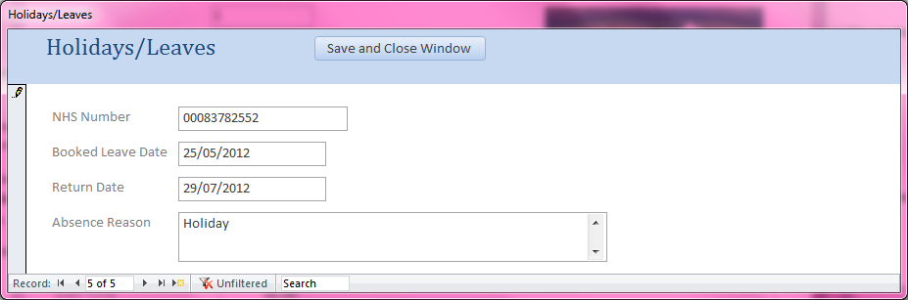

In the above pic, a demonstration is given of the information that is to be entered into the fields.

Creating a Backup[9]

1. Once the “Create Backup” button has been pressed, select the name of the database you wish to backup (normally named “Hospital Appointment System”)
2. The backup procedure will begin which will create a backup folder in the specified directory if one is not already generated.
3. The system will then generate another folder inside the backup folder which will be named as the current date and time in the format: yyyy-mm-dd hh-mm-ss
4. A message will appear notifying you if the backup was successful or if it failed.

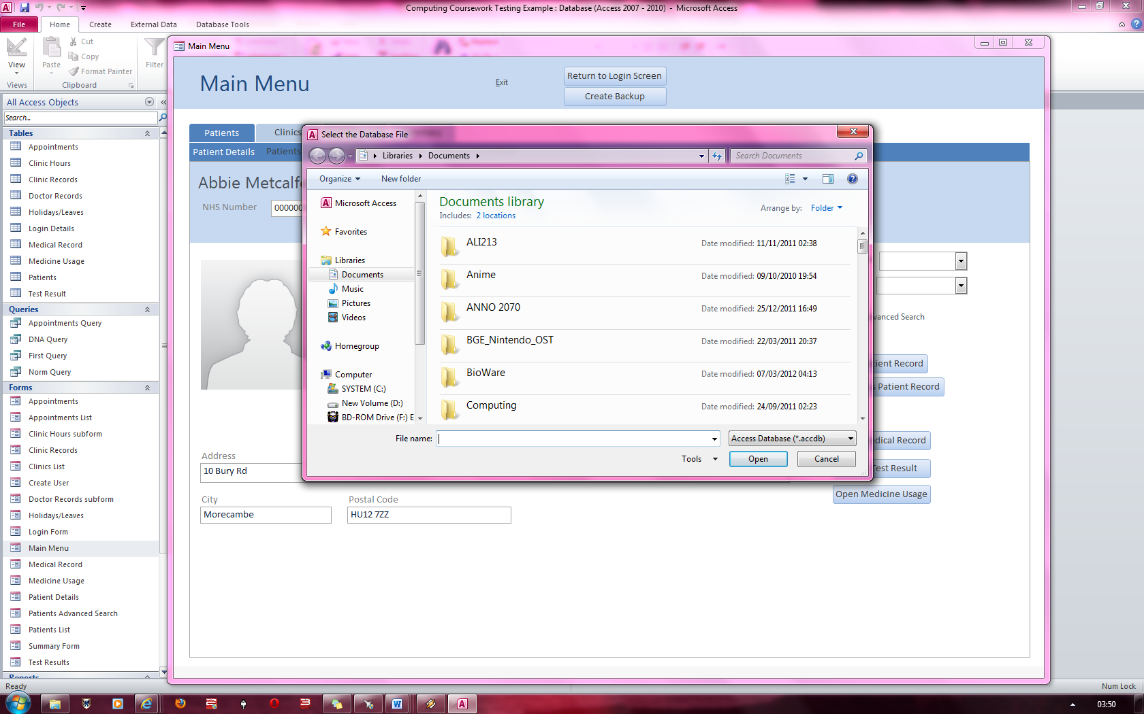

A popup box appears which enables you to select the appropriate database to backup

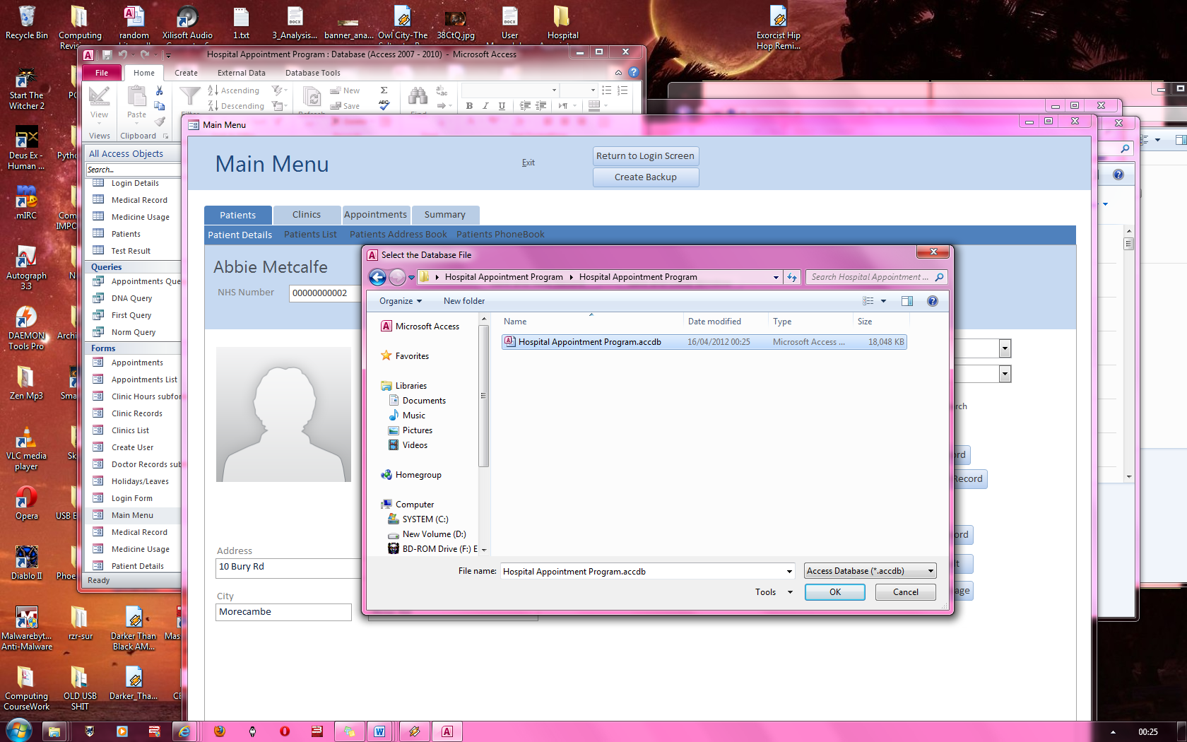The backup process is initiated and to demonstrate the process, the following database is going to be backed up.

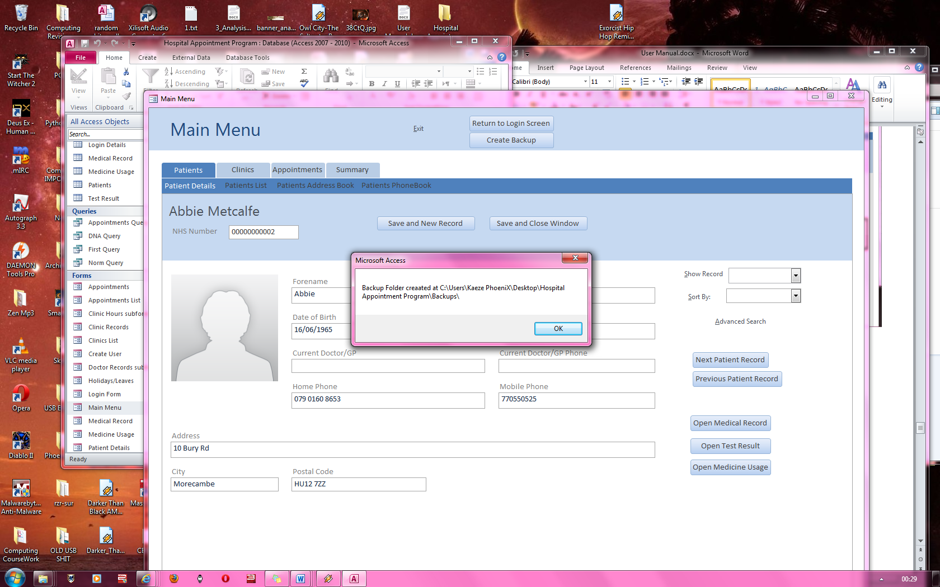If the backup process is successful (as is the case here), a message will appear stating what time the 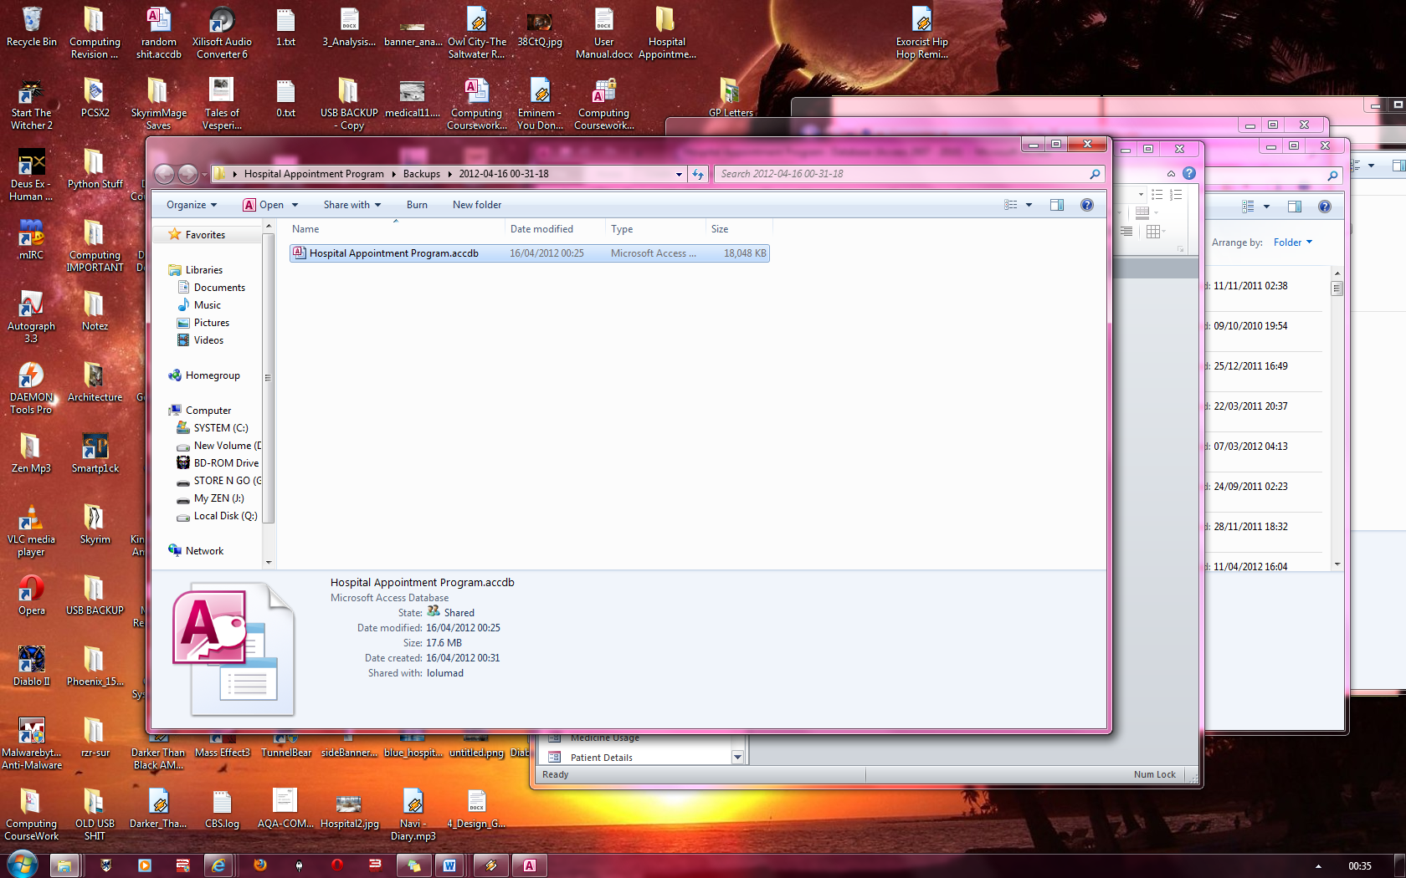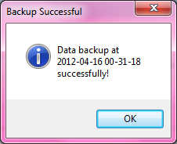backup was created.[10]

As there was no backup folder present at the folder path, the system automatically generates the backup folder as seen below.

Here the hospital Appointment Program is selected to backup.

As seen below, the program has been backed up in the folder directory: Hospital Appointment Program 🡪 Backups 🡪 2012-04-16 00-31-18

Backup Plan

The backups will have to be made every day due to the amount of appointments which are made in a single day.

Backups must also be kept offsite to avoid losing the data and it will need to be encrypted to prevent any malicious use if any unauthorized people gain access to the backups. A senior administrator to back up the changed data daily and then store it in a secure place is recommended. The backups should be kept in the password protected backup directory and all the backups should have their filenames named after the date and time that the backups were made as specified in the format stated on page 20.

Backups should also be kept for as long as they are relevant.

# Appendix

This section will cover all the error messages produced and why they are produced as well as solutions.

Login Screen Errors

|  |  |  |  |
| --- | --- | --- | --- |
| **Error(s)** | **Error(s) Caused By** | **Action(s)** | **Reference(s)** |
| **Login Failure** | No ‘Security Code’ has been entered | Enter a security code into the security code text box | Fig 1 |
| **Login Failure** | No login name has been entered | Enter a login name into the login name text box | Fig 2 |
| **Login Failure** | No password has been entered | Enter a password into the password text box | Fig 3 |
| **Login Failure** | No user group has been selected | Selected a user group from the user group drop down list | Fig 4 |
| **Login Failure** | Length of ‘Security Code’ is incorrect | Make sure you have entered 17 characters into the security code text box | Fig 5 |
| **Login Failure** | Password is less than 6 characters | Make sure the password length is less than 6 characters | Fig 6 |
| **Login Failure** | Password is greater than 24 characters | Make sure the password length is greater than 24 characters | Fig 7 |
| **Login Failure** | Login details are incorrect.[11] | If none of the above causes are true then check if you have entered the correct login details | Fig 8 |

Backup Procedure Errors

|  |  |  |  |
| --- | --- | --- | --- |
| **Error(s)** | **Error(s) Caused By** | **Action(s)** | **Reference(s)** |
| **Backup Failed** | Clicking cancel on the dialog box | Press OK on the error messages and restart the backup procedure and select a file | Fig 9, Fig 10 |

Validation Errors

|  |  |  |  |
| --- | --- | --- | --- |
| **Error(s)** | **Error(s) Caused By** | **Action(s)** | **Reference(s)** |
| **No Data has been Entered** | Not entering data into a required field | Press OK on the error message and enter some data into the textbox which has produced the error | Fig 11 |
| **Data has incorrect data types entered** | Entering an incorrect data type into a field | Press OK on the error message and enter only text in fields such as forename and only numbers into fields such as home phone number. | Fig 12, Fig 13 |

**Error(s)**

**Error(s) Caused By**

Advanced Search Errors

|  |  |  |  |
| --- | --- | --- | --- |
| **Error(s)** | **Error(s) Caused By** | **Action(s)** | **Reference(s)** |
| **No Data has been Entered** | Not entering data into a field that has been checked | Enter some data into the field which has no data in whilst having its checkbox checked. | Fig 14 |
| **A checkbox has not been checked whilst data has been entered into the relevant field** | Not checking a checkbox whilst entering data into the associated text box | Check to see if all textboxes which have data entered into them have their associated check boxes checked | Fig 15 |
| **Data has not been entered into a field but a checkbox has been checked** | Checking a check box whose associated text box has no data entered into it | Check that if all empty text boxes have had their associated checkboxes unchecked | Fig 16 |
| **No record has been found with the criteria entered** | No record containing the data you have filtered the patient form by. | Check if the data you have entered is correct. If it is, then no record has been found and a new record needs to be created. | Fig 17 |

Appointment Form Errors

|  |  |  |  |
| --- | --- | --- | --- |
| **Error(s)** | **Error(s) Caused By** | **Action(s)** | **Reference(s)** |
| **Both check boxes have been checked** | Not entering data into a field that has been checked | Enter some data into the field which has no data in whilst having its checkbox checked. | Fig 18 |

**)**

**Reference(s)**

Check Valid Date Errors

|  |  |  |  |
| --- | --- | --- | --- |
| **Error(s)** | **Error(s) Caused By** | **Action(s)** | **Reference(s)** |
| **The date entered conflicts with another date and time for the same clinic** | Entering a date and time for a clinic which has already been assigned to another appointment | Modify the current appointment time, date and assigned clinic such that it does not conflict with another appointment | Fig 19 |

Holiday/Leave Form Errors

|  |  |  |  |
| --- | --- | --- | --- |
| **Error(s)** | **Error(s) Caused By** | **Action(s)** | **Reference(s)** |
| **An appointment has been entered at a clinic which has no doctor available.** | Creating an appointment for a clinic which has no doctor available | Change the clinic assigned to the appointment. | Fig 20 |
| **A leave date has been entered which is at an earlier date than the current date** | Entering a leaved date which is earlier than the current date | Change the return date or leave date for the holiday/leave such that the return date is further ahead of the present date | Fig 21 |

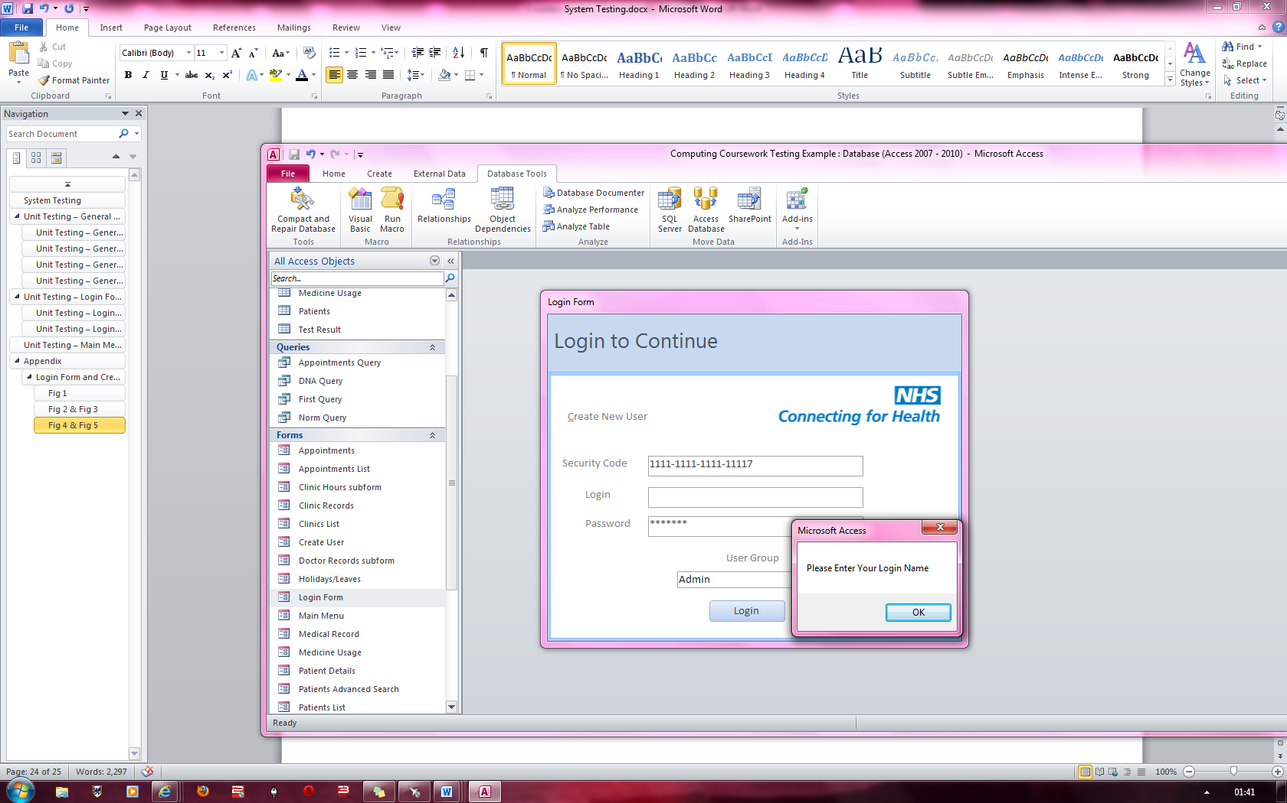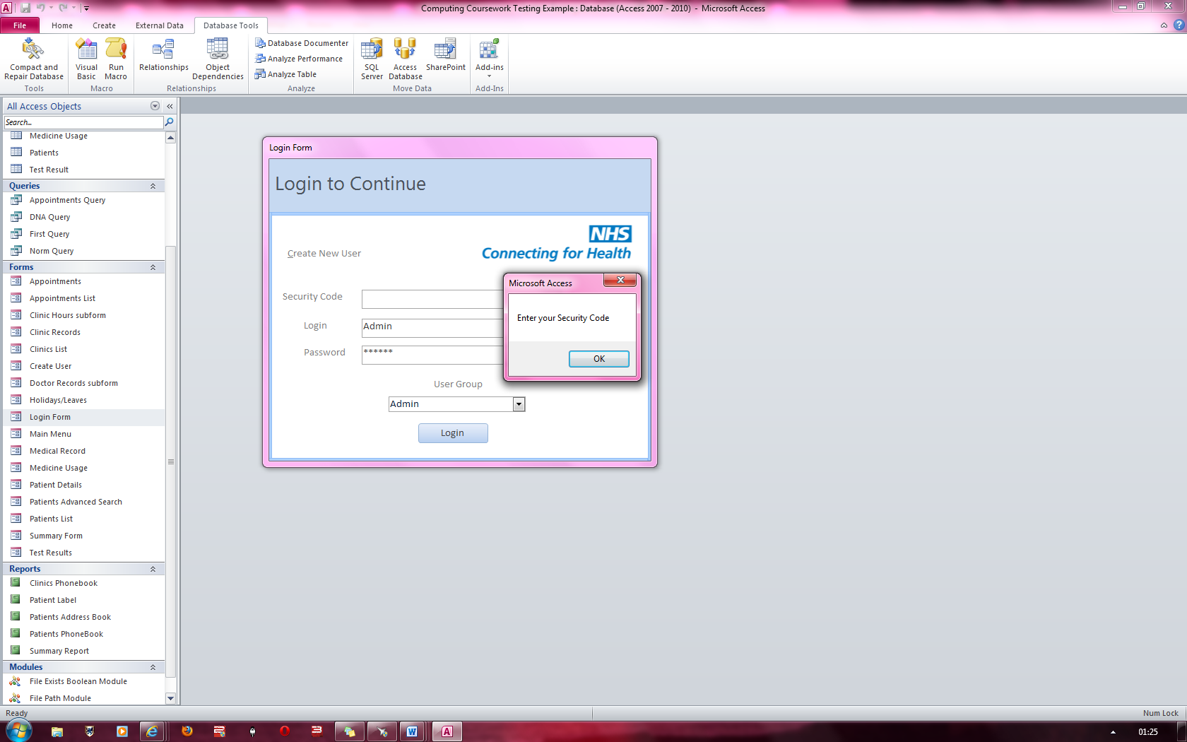

**FIG 1**

No Login name has been entered

An error message appears stating a login name must be entered.

No Security Code has been entered

Error Message stating that a “Security Code” must be entered for the system to login.

**FIG 2**

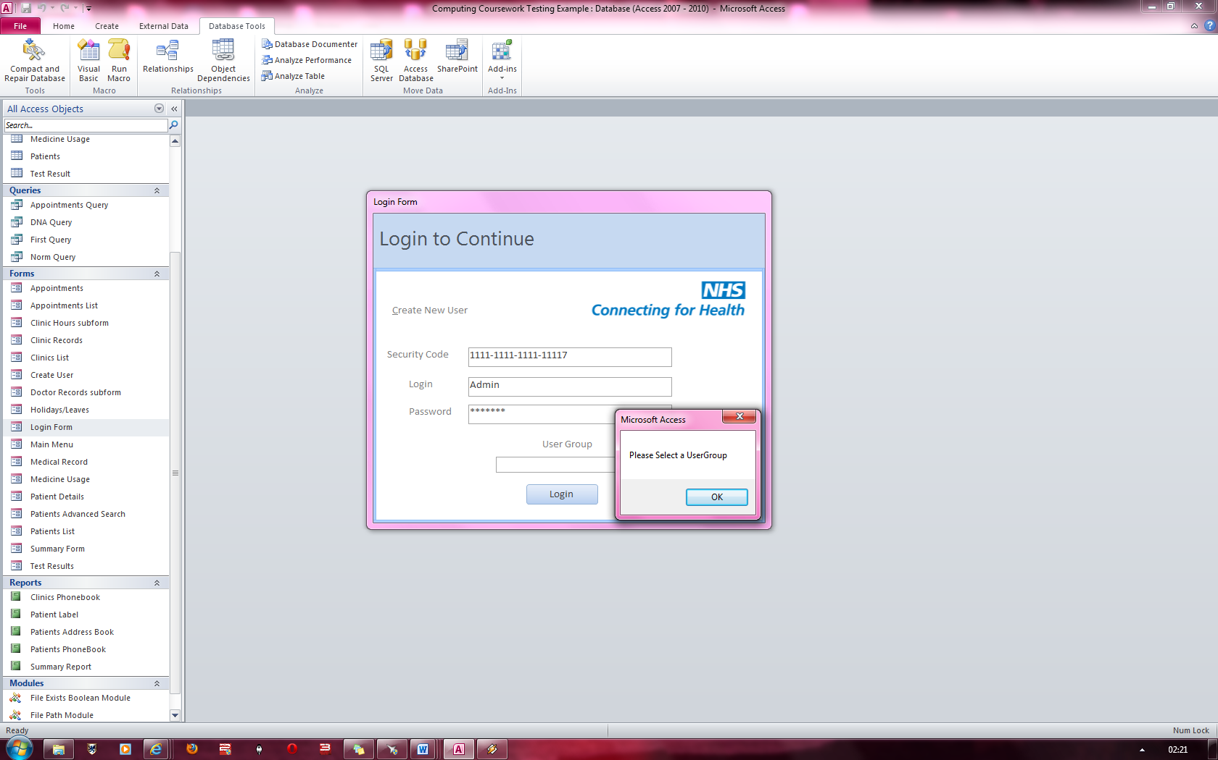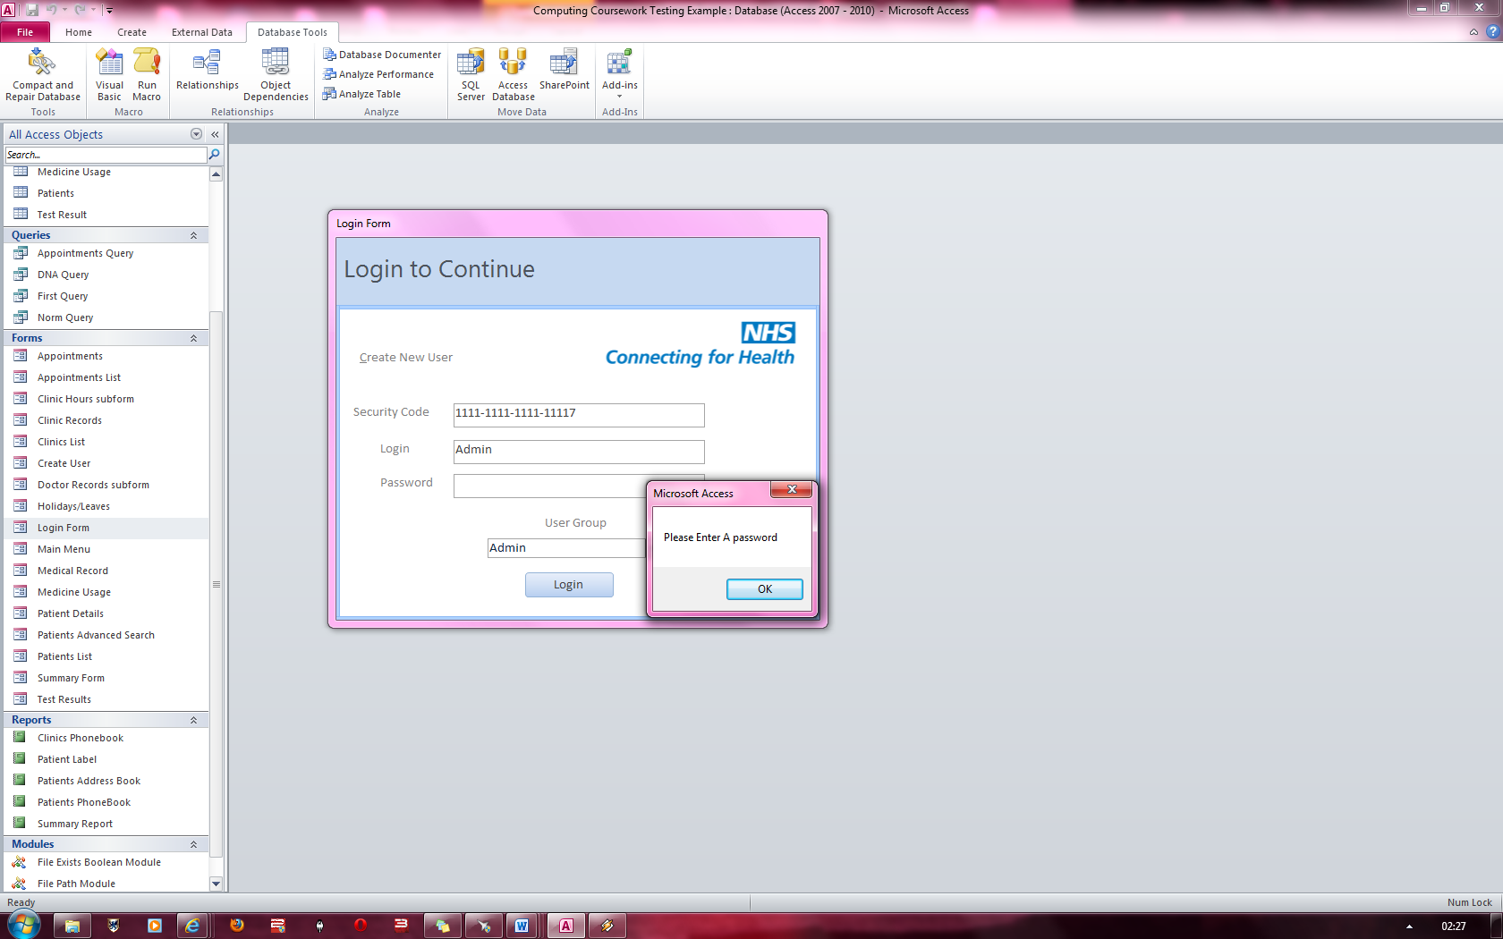

**FIG 4**

A ‘User Group’ has not been selected and so the program produces an error message stating that a user group must be selected.

**FIG 3**

“Please Enter a Password” error message appears which prevents the user from logging in.

‘Password ‘is empty

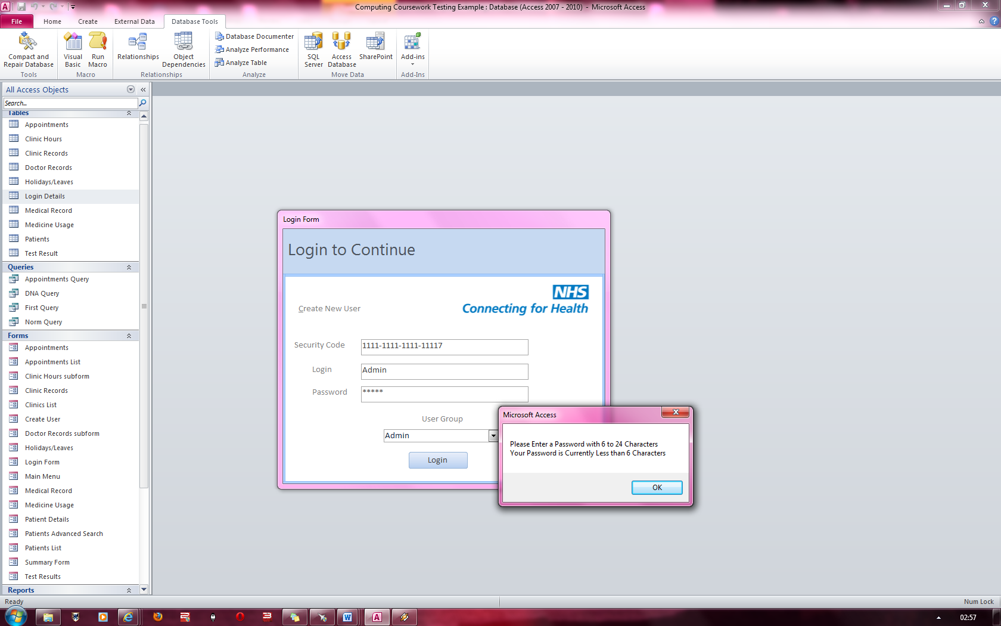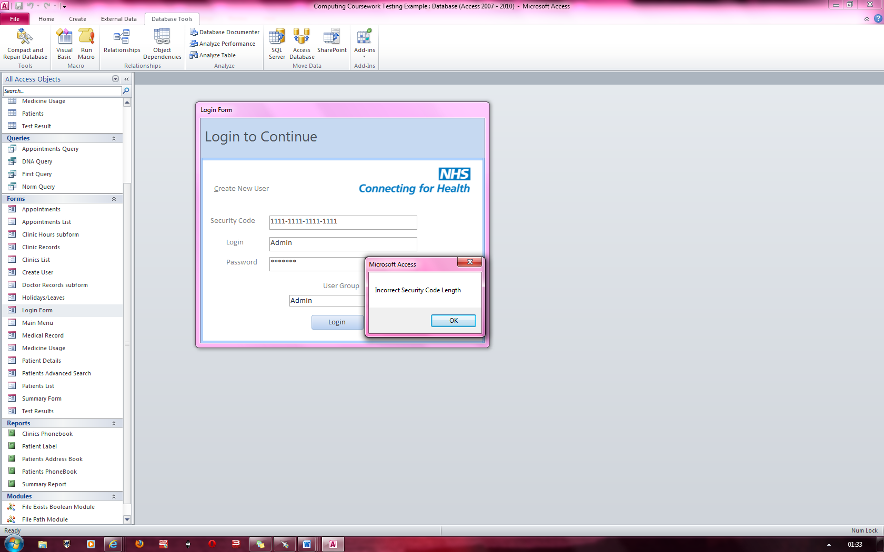

**FIG 6**

**FIG 5**

‘Password ‘is 5 characters long

Error Message stating that Security code is of an incorrect length which prevents the user from logging in

Above is an Error message stating that the password must be between 6 and 24 characters. This prevents the user from logging in

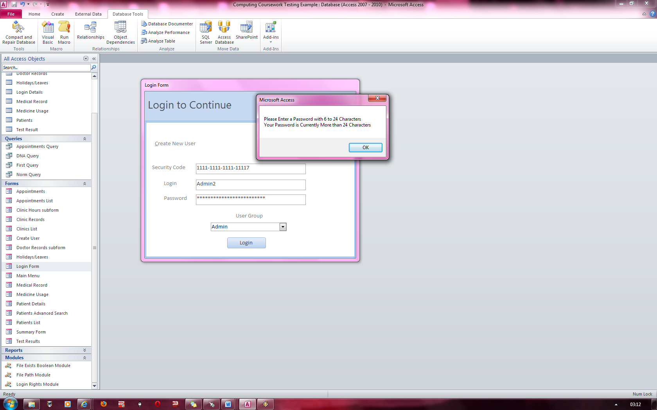

**FIG 7**

‘Password ‘is 26 characters long

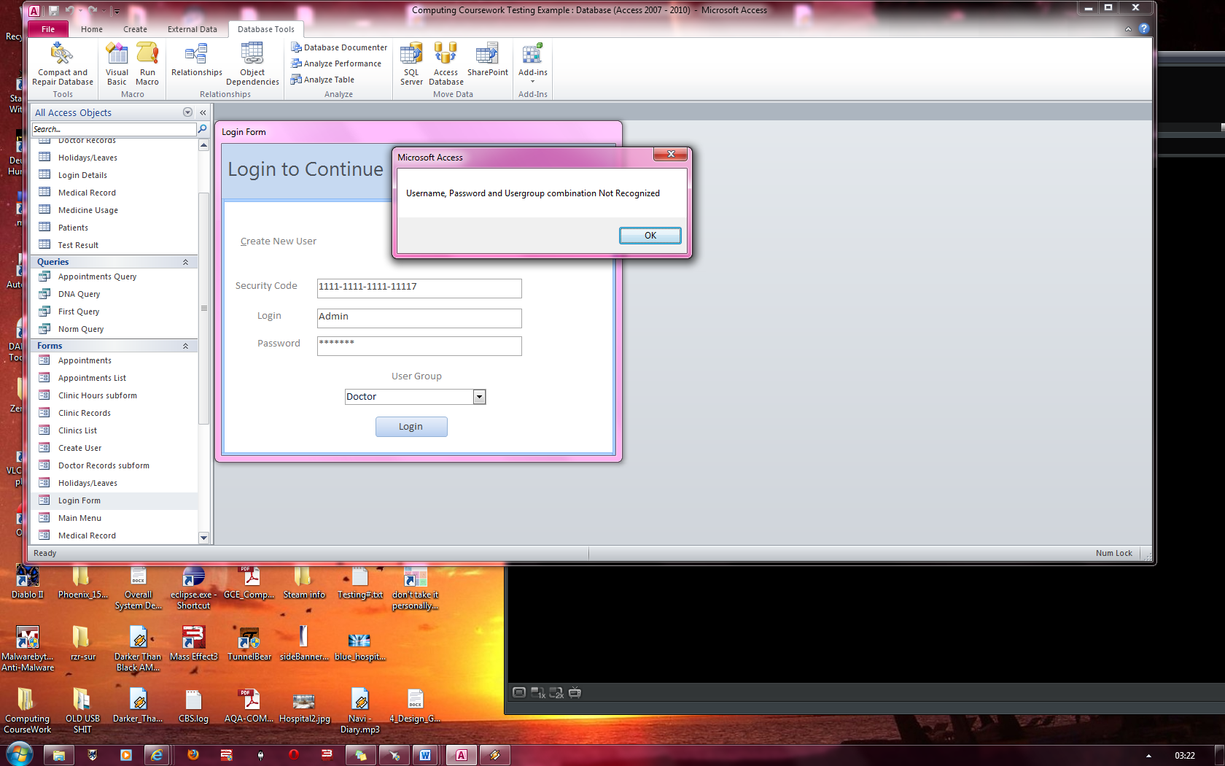

If no other errors occur, and this error message appears, you most likely have entered incorrect details into the system

**FIG 8**

Error message stating that the password must be between 6 and 24 characters

This prevents the user from logging in

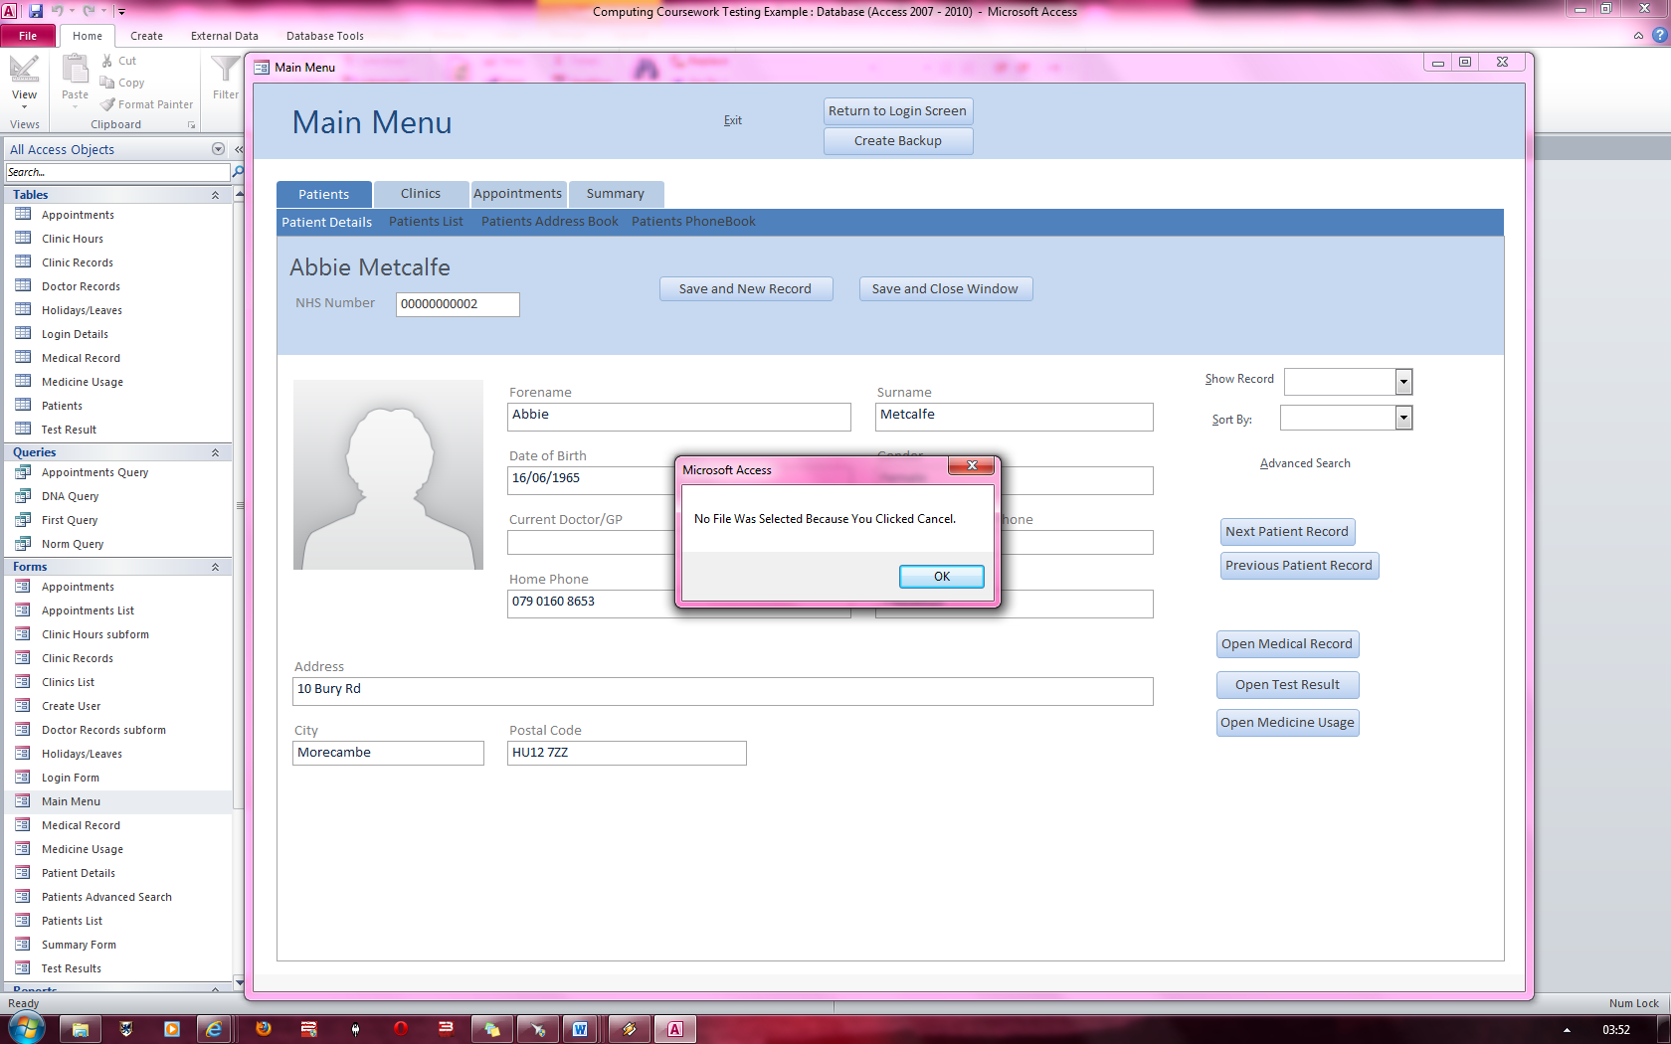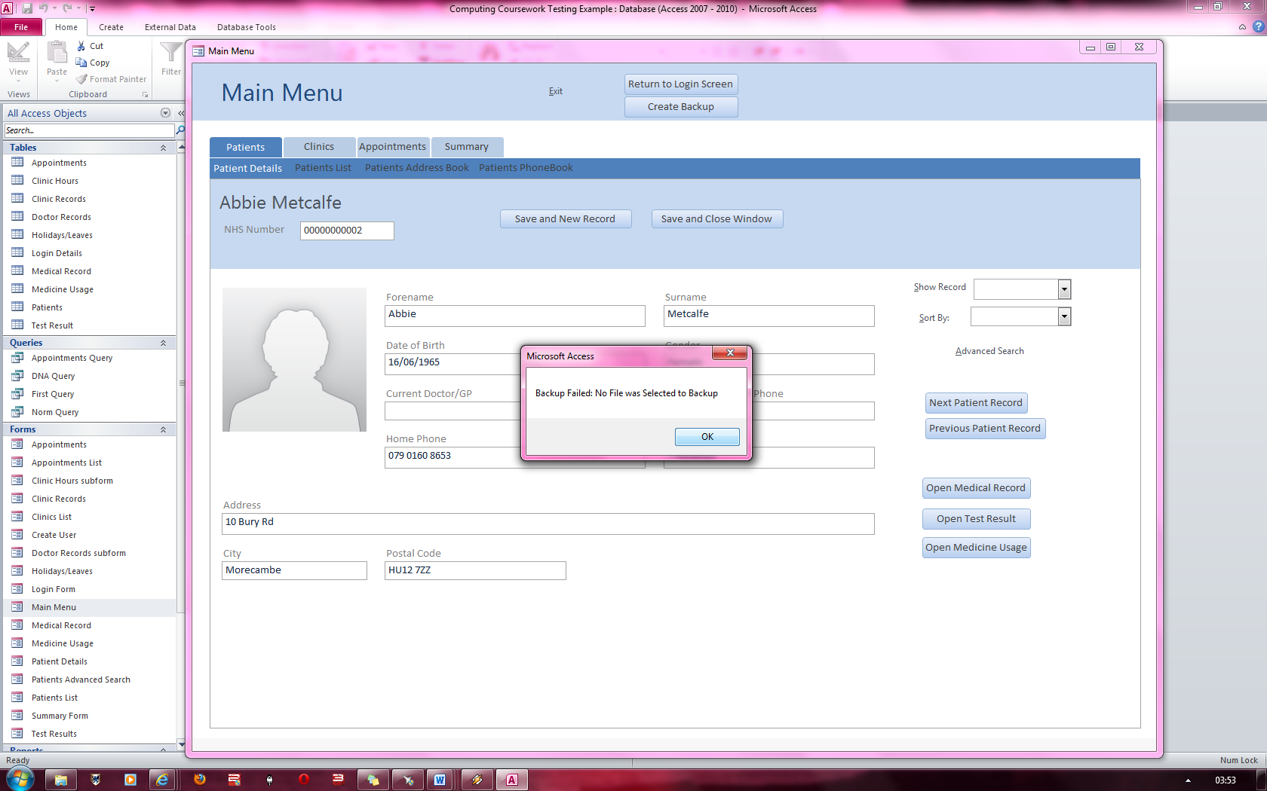

Error message stating backup failed because no file was selected to backup

Error message stating that no file was selected to backup

**FIG 9**

**FIG 10**

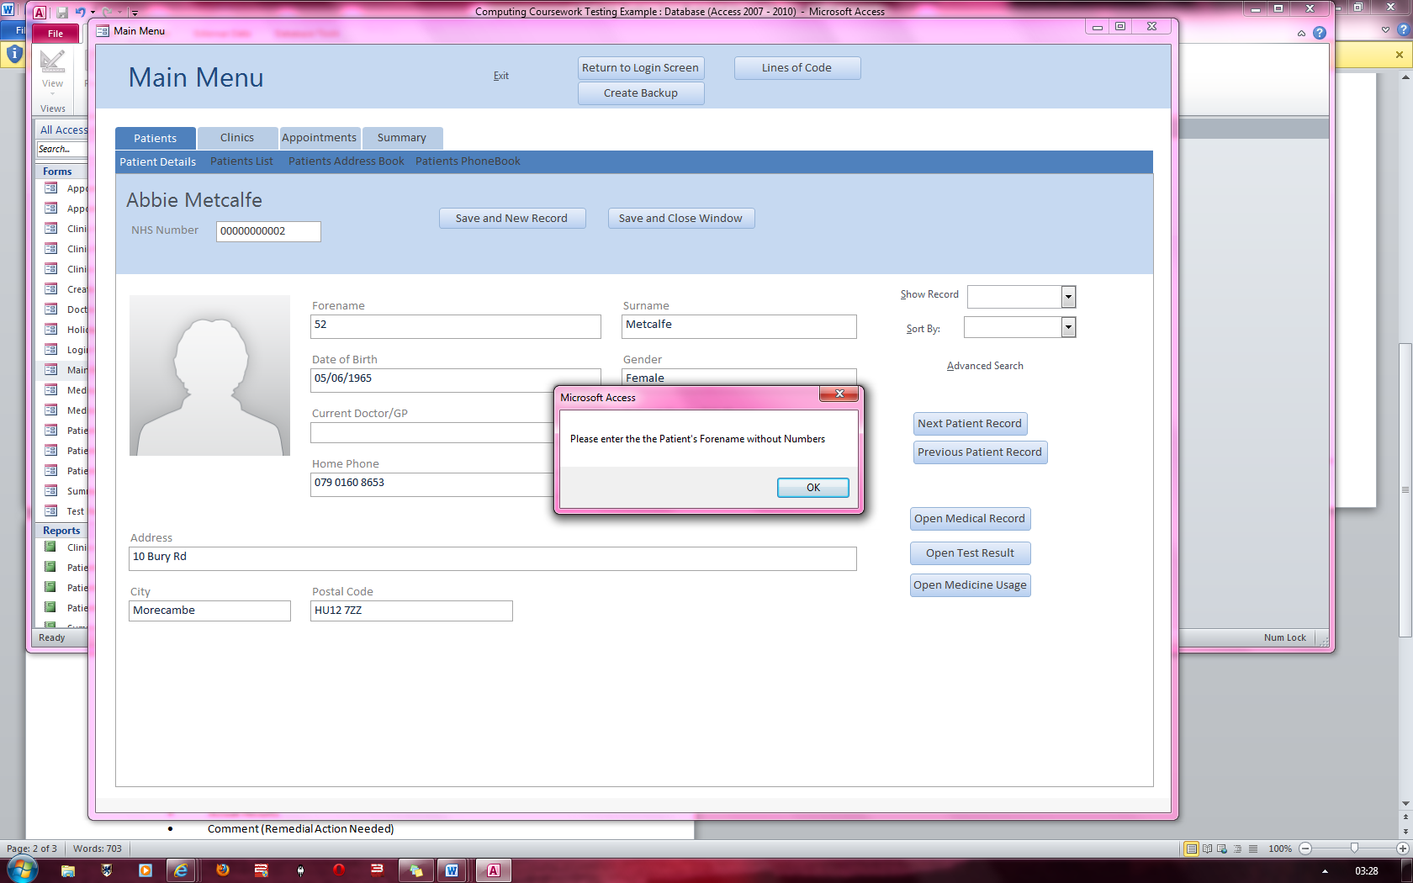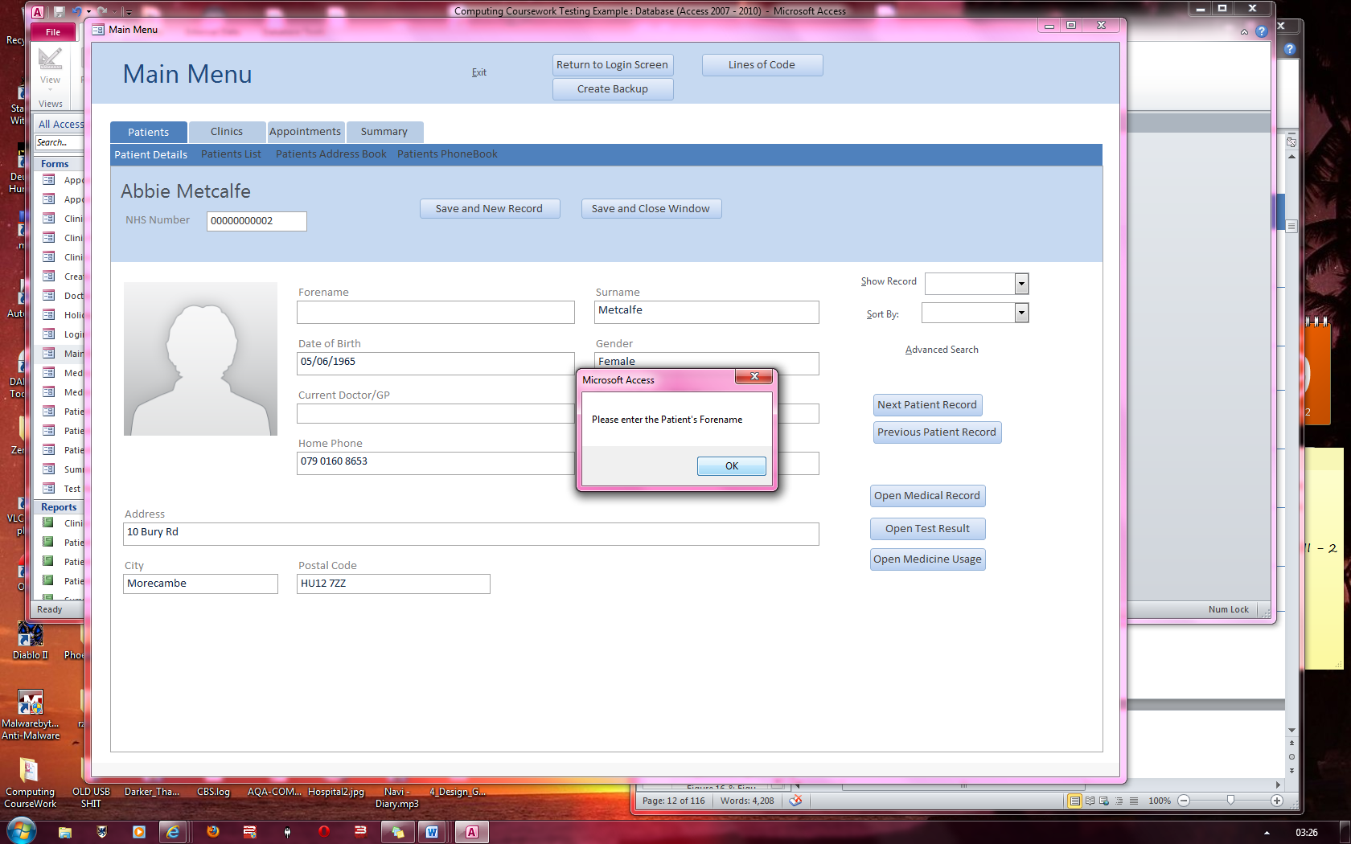

No data has been entered into the forename text box.

The number “52” has been entered into the forename textbox which produces the following error message.

**FIG 12**

**FIG 11**

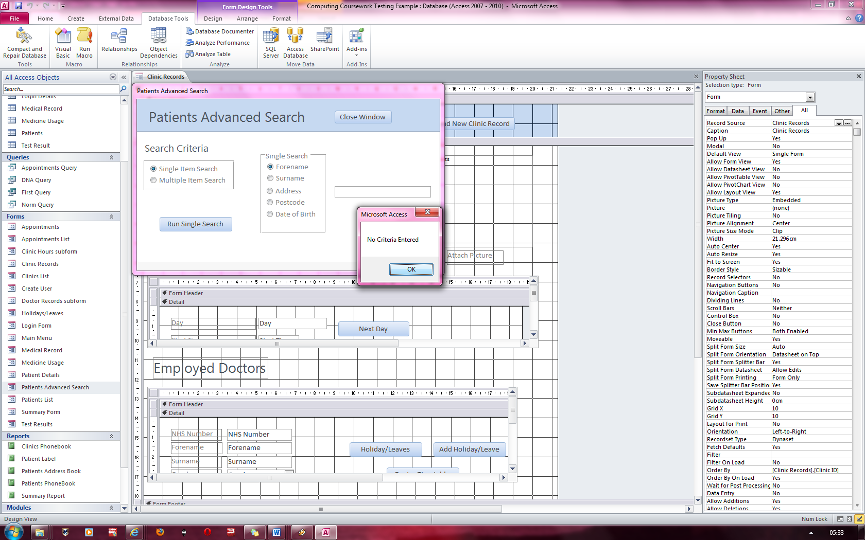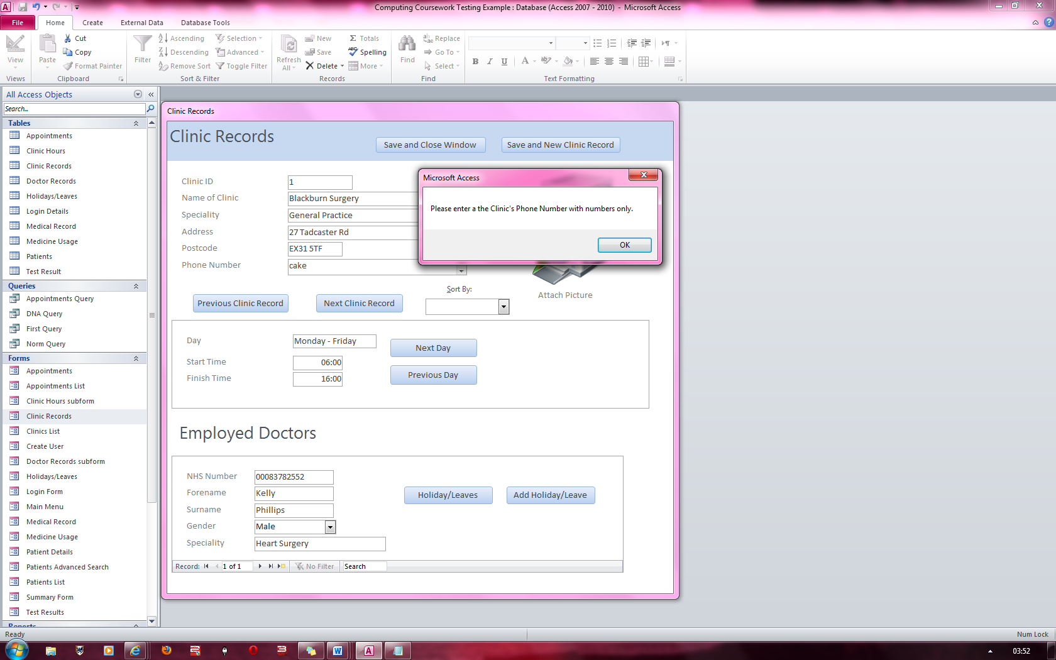

No data has been entered into the field when forename has been checked.

**FIG 14**

The word “cake” has been entered into the phone number text box.

**FIG 13**

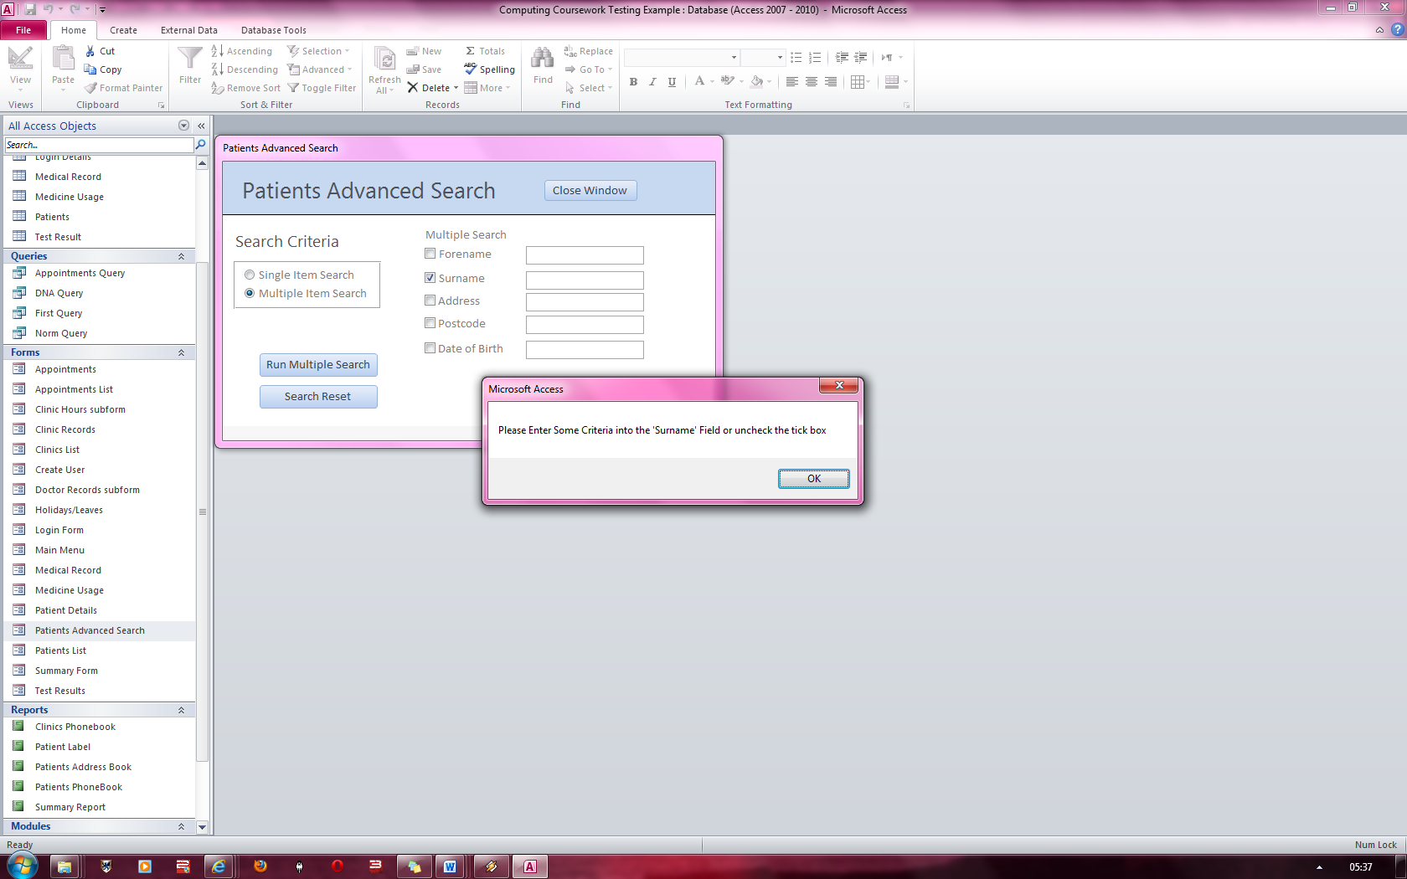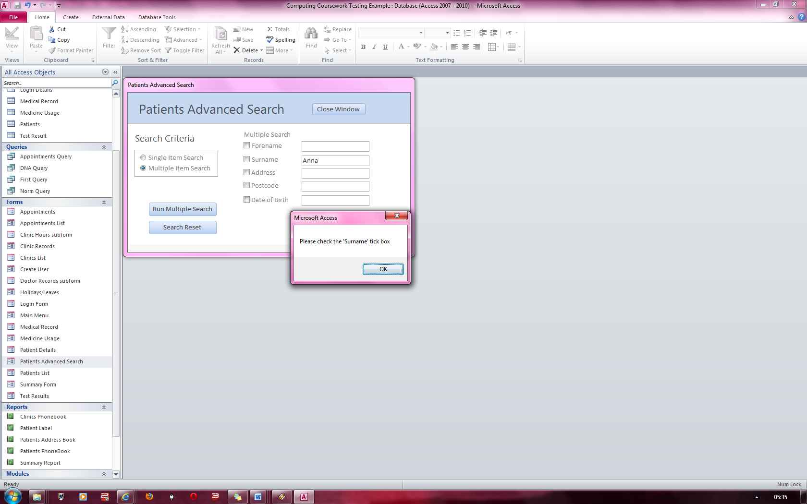

Here the Surname checkbox has been checked, but no criteria have been entered into the associated text box.

The surname checkbox has not been checked whilst data has been entered into the surname field

**FIG 16**

**FIG 15**

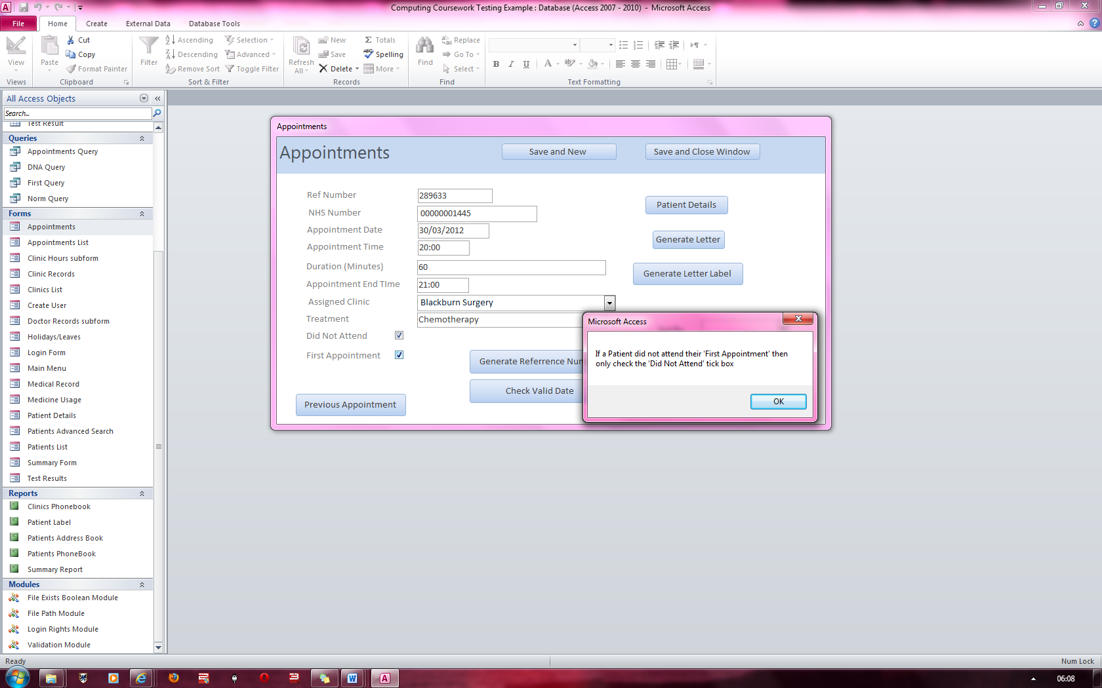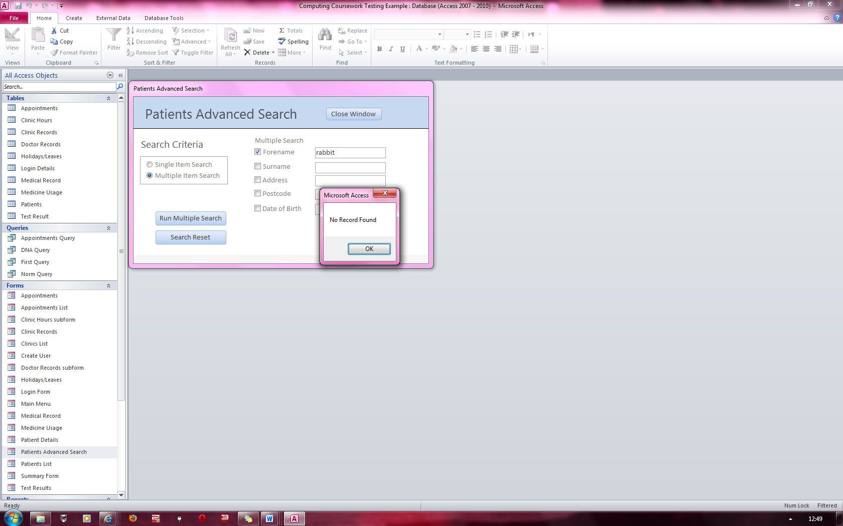

An error message appears stating that both checkboxes cannot be checked and then proceeds to uncheck the “First Appointment” checkbox.

**FIG 18**

Here, the forename checkbox is checked and in the associated textbox, “rabbit” is written. An error message is displayed stating that no record has been found with that forename

**FIG 17**

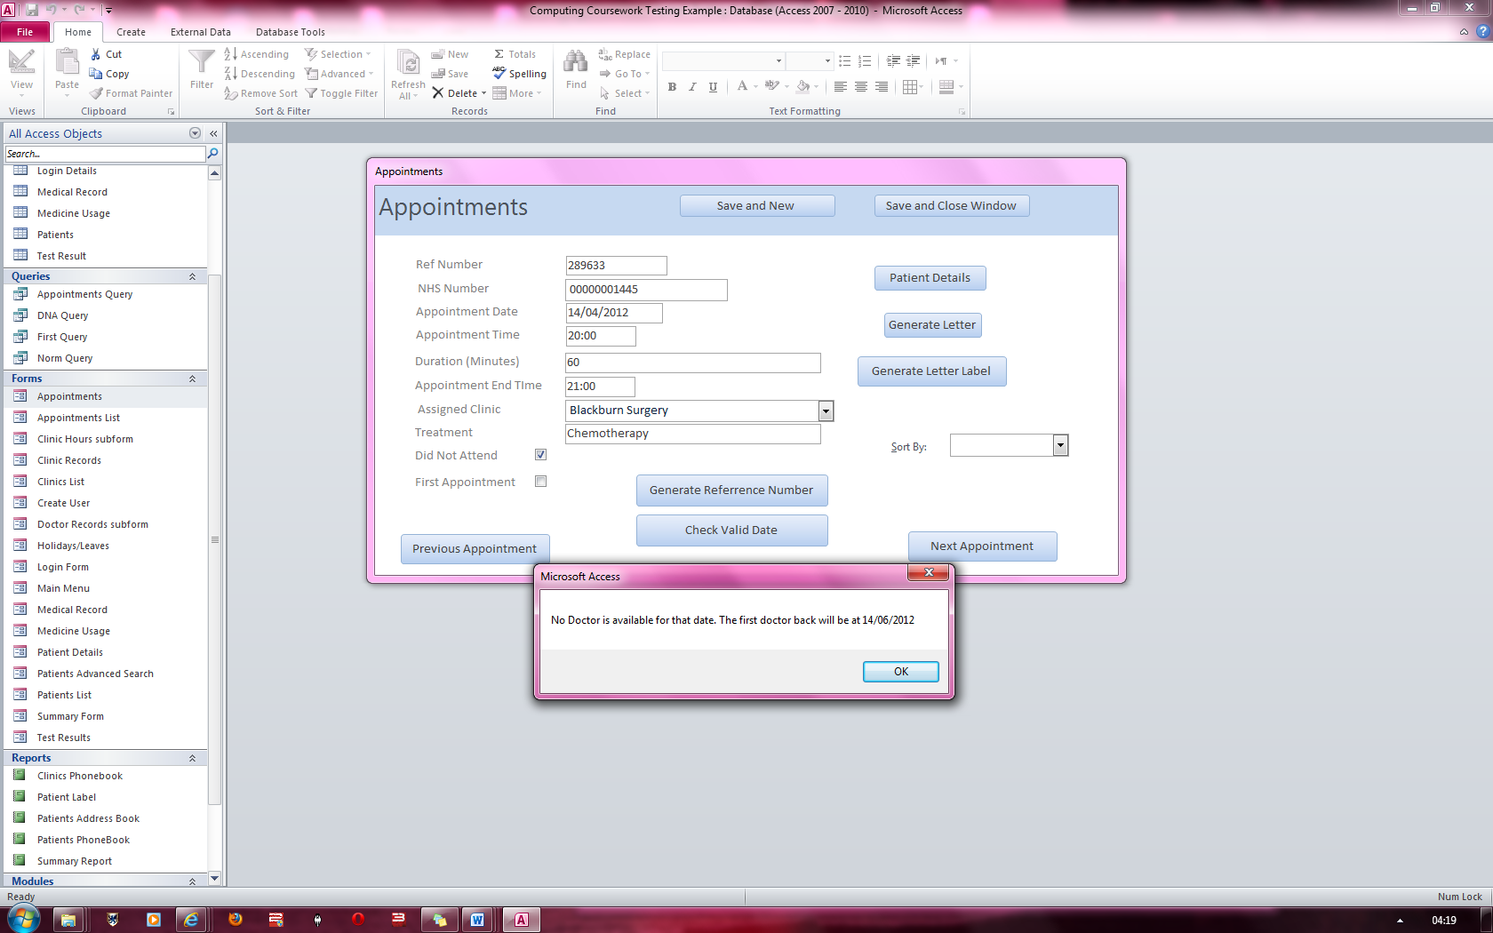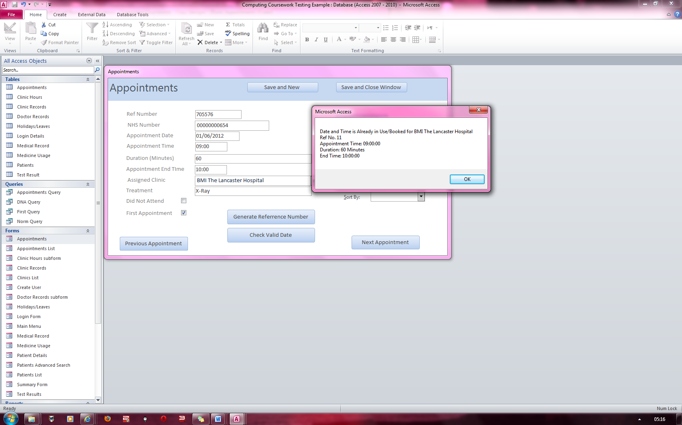

An error message stating that there is no available doctor for the specific clinic and the date when the first doctor available will be back

**FIG 20**

An error message appears stating that the date, time and assigned clinic entered conflicts with another appointment’s date, time and assigned clinic and shows which appointment it conflicts with. Note the different reference numbers for the appointment.

**FIG 19**

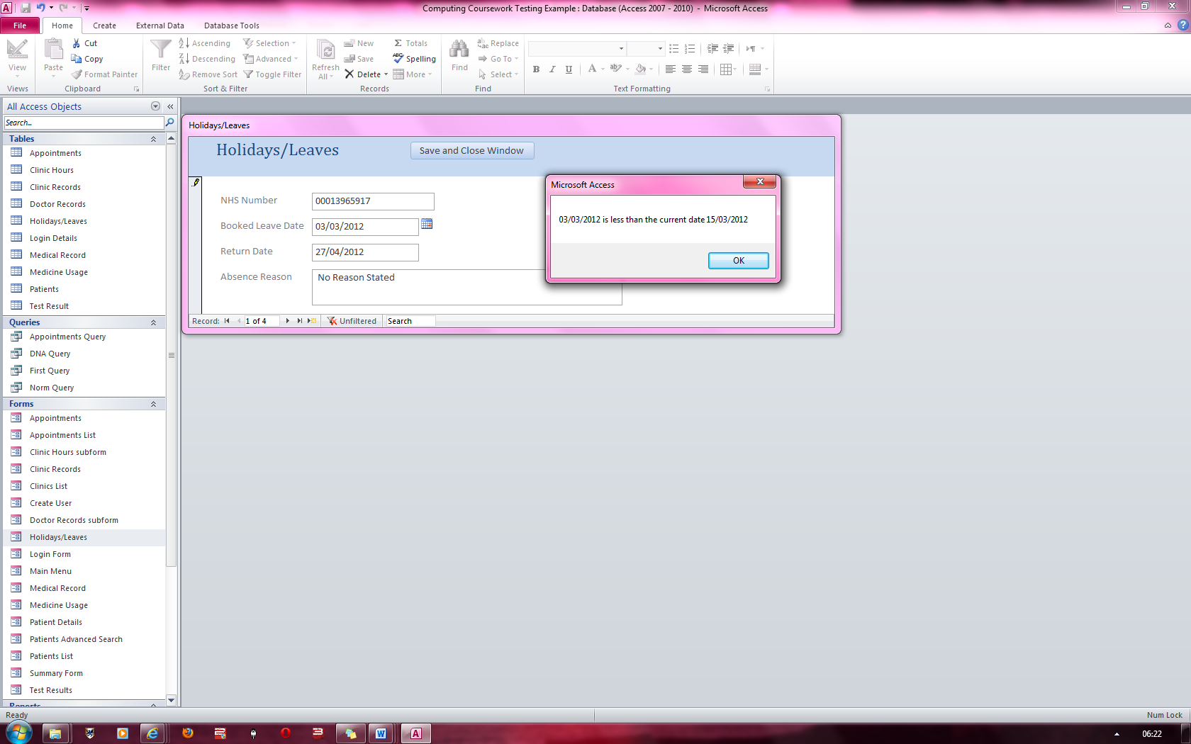

Above is an error message stating that the booked leave date is set to an earlier date than the current date and therefore, cannot be input.

**FIG 21**

1. The record that it navigates to is dependent on what the records are sorted by i.e. If a record set had the name of a person ordered alphabetically, the next record it would navigate to after all the records with the letter “A” had ended would be the record starting with the letter “B”.
2. Refer to Appendix for a list of all error messages associated with the Login Screen.
3. For demonstration purposes, the system’s code has been modified to allow the security code 1111-1111-1111-11117.
4. Error Messages produced by the validation system is shown in the Appendix
5. All the relevant error messages produced by the advanced search form can be seen in the Appendix of the user manual.
6. Refer to the Appendix for the relevant errors which may be produced by the Appointment form.
7. Error messages pertaining to the “Check Valid Date” function are available in the appendix.
8. Error messages pertaining to the “Holiday/Leaves” form are available in the Appendix.
9. Modifying the path where the backup is saved can be done by modifying the code of the program. Contact an Admin to change the directory.
10. All error messages relating to the backup procedure are present in the Appendix.
11. If your login details are correct and the system is not allowing you access into the system, please contact someone who has admin rights to the system who will be able to assist you further.